
Touchstones REACH
Touchstones REACH (Religious Education Arts Clearing House)

Lifespan RE Resources for Emotional Intelligence

Introduction
This packet provides resources on the theme of Emotional Intelligence, generally, and emotions, specifically. While the UUA’s Tapestry of Faith has some stories involving emotions, the theme is not addressed.
Principles that bear upon emotions and emotional intelligence are 1) The inherent worth and dignity of every person; 2) Justice, equity, and compassion in human relations; 3) Acceptance of one another and encouragement to spiritual growth in our congregations; 4) A free and responsible search for truth and meaning; and 6) The goal of world community with peace, liberty, and justice for all.
Because experience is a primary source of authority in liberal religion, emotional intelligence is an important tool in making sense of our experience.
The best way to address emotions is by using the 2015 Disney/Pixar film Inside Out and/or clips from the movie. (See 5.0. A synopsis of the movie is at 5.)
Comprehensive activities that are user friendly for emotional intelligence are referenced at 6.0 and 8.2. These can be used in class and at home.
For younger children, the exploration of emotions is more appropriate and accessible, than emotional intelligence.

The Study of Emotions
The study of emotions is ancient. Aristotle attempted to identify core emotions and concluded that there were 14: fear, confidence, anger, friendship, calm, enmity, shame, shamelessness, pity, kindness, envy, indignation, emulation, and contempt.
In 1872, Charles Darwin published The Expression of the Emotions in Man and Animals. He theorized that emotions were innate, evolved, and had a functional purpose. He did not enumerate basic emotions, but likely envisioned a shorter list including fear, anger, sadness, happiness, and love.
In 1980, Robert Plutchik created a wheel of emotions that proposed eight basic emotions—joy, sadness, trust, disgust, fear, anger, surprise, and anticipation. Blends of these led to secondary and tertiary emotions. Anticipation plus joy might combine to form optimism, while fear and surprise might together describe awe. Many have questioned this model since secondary and complementary emotions may vary by culture or society.
As early as 1972, based on facial coding, Paul Ekman proposed that there are seven emotional expressions universal to people all over the world: happiness, sadness, surprise, fear, anger, disgust, and contempt. He later revised this to six when he dropped contempt from the list. The 2015 Pixar/Disney movie Inside Out uses five of these: happiness, sadness, fear, anger, and disgust.
In 2014, a research group proposed four basic emotions: happiness, sadness, fear, and anger, while a 2017 study identified 27 unique emotions: admiration, adoration, aesthetic appreciation, amusement, anger, anxiety, awe, awkwardness, boredom, calmness, confusion, craving, disgust, empathic pain, entrancement, excitement, fear, horror, interest, joy, nostalgia, relief, romance, sadness, satisfaction, sexual desire, surprise.
A chart of blended emotions based on the five emotions in the movie Inside Out can be found at 11.1.

Emotional Intelligence
Peter Salovey and John D. Mayer first formally defined the term “Emotional Intelligence” (EI) in an academic journal in 1990. They described it as “the ability to monitor one’s own and others’ feelings and emotions, to discriminate among them, and to use this information to guide one’s thinking and actions.” This concept was then popularized by Daniel Goleman in his 1995 book, Emotional Intelligence: Why It Can Matter More than IQ.

Other Resources
How to Strengthen Your Child’s Emotional Intelligence by Meghan Owenz
Link: https://www.gottman.com/blog/strengthen-childs-emotional-intelligence/
Raising Emotionally Intelligent Children by Jeanne Segal, Ph.D.
Link: https://www.helpguide.org/articles/mental-health/raising-emotionally-intelligent-children.htm
The Heart of Parenting: Nonviolent Communication in Action by Marion Badenoch Rose, Ph.D.
This is a nice overview of the use of nonviolent communication (NVC) with children. NVC is a process that helps cultivate emotional intelligence.
Link: https://www.nonviolentcommunication.com/pdf_files/parenting_communication_mrose.pdf
How Can We Help Kids with Self-Regulation?
Link: https://childmind.org/article/can-help-kids-self-regulation/
Kindness Curriculum by Richard Davidson
Link: https://centerhealthyminds.org/join-the-movement/sign-up-to-receive-the-kindness-curriculum

List of Resources
1.0: Pins
Resources for Children
2.0: Children’s Homilies, Sermons, Time for All Ages & Resources
2.1: Fair vs. Equal by Rev. Erika A. Hewitt (507 words)
3.0: Wisdom Stories
Anger
3.1: Mussa and Nagib (484 words)

3.2: The Answer is in Your Hands, adapted from an Indian folk tale (580 words)

3.3: Anger A Buddhist Story by Sarah Conover (345 words)

3.4: The Dervish in the Ditch (263 words)

3.5: Ruby Bridges, Surrounded by Love by Janeen Grohsmeyer (718 words)

3.6: The Stolen Soup Aroma, from the All Folk Tales website. (473 words)

3.7: The Tennessee Valley Unitarian Universalist Church Shooting (473 words)

3.8: Margaret Fuller’s Mystical Experience (1,311 words)

3.10: Amy by William F. Schulz (347 words)
Fear

3.11: A Private History of Awe (220 words)

3.12: Life of an Ally (795 words)

3.13: Hosea Ballou’s Conversion (577 words)
Sadness
No stories identified.
Happiness

3.14: How Coyote Lost His Songs, Music, And Dance by Rev. Kenneth W. Collier (1,330 words)

3.15: The Sword of Wood, A Jewish tale from Afghanistan (1,138 words)

3.16: The Stonecutter, based on a wisdom tale of Japanese origin (585 words)

3.17: The Mish-Mash Heart (438 words)

3.18: Clowning for Joy in Haiti by Sarah Foster (852 words)

3.19: Lizard’s Song (459 words)
4.0: Children’s Books about Emotions

Emotions / Feelings (General)

4.1: The Good Little Book by Kyo Maclear (Author), Marion Arbona (Illustrator) (2015)

4.2: My Many Colored Days by Dr. Seuss by (Author), Steve Johnson (Illustrator) & Lou Fancher (Illustrator) (1996)

4.3: Tiger Days: A Book of Feelings by M.H. Clark (Author), Anna Hurley (Illustrator) (2019)

4.4: In My Heart: A Book of Feelings by Jo Witek (Author) Christine Roussey (Illustrator) (2014)

4.5: How Do You Feel? by Lizzy Rockwell (2019)

4.6: My Heart by Corinna Luyken (2019)

4.7: The Color Monster by Anna Llena (Author) (2018)
4.8: Lots of Feelings by Shelley Rotner (Author) (2003)
4.9: Grumpy Monkey by Suzanne Lang (Author), Max Lang (Illustrator) (2018)
4.10: The Pout Pout Fish by Deborah Diesen (Author), Dan Hanna (Illustrator) (2008)
4.11: Stand Tall, Molly Lou Melon by Patty Lovell (Author), David Catrow (Illustrator) (2001)

4.12: Spaghetti in A Hot Dog Bun: Having the Courage to Be Who You Are by Maria Dismondy (Author), Kimberly Shaw-Peterson (Illustrator) (2008)

4.13: Today I Feel Silly: And Other Moods That Make My Day by Jamie Lee Curtis by Jamie Lee Curtis (Author), Laura Cornell (Illustrator) (1998)

4.14: Visiting Feelings by Lauren J. Rubenstein JD PsyD (Author), Shelly Hehenberger (Illustrator) (2013)

Anger

4.15: When Sophie Gets Angry—Really, Really Angry by Molly Bang (3:12)

4.16: The Snurtch by Sean Ferrell (Author), Charles Santoso (Illustrator) (2016)

4.17: Anh’s Anger by Gail Silver (Author), Christianne Kromer (Illustrator) (2009)

4.18: Field Guide to the Grumpasaurus by Edward Hemingway (Author) (2016)

4.19: Alexander and the Terrible Horrible No Good Very Bad Day by Judith Viorst (Author), Ray Cruz (Illustrator) 2009

Fear

4.20: Me and My Fear by Francesca Sanna (Author) (2018)

4.21: Take a Deep Breath by Sue Graves (Author), Desideria Guicciardini (Illustrator) (2013)

4.22: After the Fall (How Humpty Dumpty Got Back Up Again) by Dan Santat (Author, Illustrator) (2017)

4.23: Little Tree by Loren Long (Author, Illustrator) (2015)

4.24: Good People Everywhere by Lynea Gillen (Author), Kristina Swarner (Illustrator) (2012)

4.25: I Need my Monster by Amanda Noll (Author), Howard McWilliam (Illustrator) (2009)

Sadness (and Grief)

4.26: Don’t Need Friends by Carolyn Crimi (Author), Lynn Munsinger (Illustrator) (2001)

4.27: When Sadness is at Your Door by Eva Eland (Author) (2019)

4.28: I’m Sad by Michael Ian Black (Author), Debbie Ridpath Ohi (Illustrator) (2018)

4.29: The Rough Patch by Brian Lies (Author, Illustrator) (2018)

4.30: The Day You Begin by Jacqueline Woodson (Author), Rafael López (Illustrator) (2018)

4.31: What to Do When You’re Feeling Blue by Andi Cann (Author) (2019)

4.32: Rabbit and the Motorbike by Kate Hoefler (Author), Sarah Jacoby (Illustrator) (2019)

4.33: Maybe Tomorrow? by Charlotte Agell (Author), Ana Ramírez González (Illustrator) (2019)

4.34: Virginia Wolf by Kyo Maclear (Author), Isabelle Arsenault (Illustrator) (2012)

4.35: The Boy Who Didn’t Want to Be Sad by Dr. Robert Goldblatt PsyD (Author, Illustrator) (2004)

4.36: Goodbye, Brecken by David Lupton (Author, Illustrator) (2013)

Happiness

4.37: Across the Blue Mountains by Emma Chichester Clark (1993)

4.38: My Heart Fills With Happiness by Monique Gray Smith (Author), Julie Flett (Illustrator) (2016)

4.39: Pass it On by Sophy Henn (Author, Illustrator) (2017)

4.40: Augustus and His Smile by Catherine Rayner (Author) (2007)

4.41: Other Books About Emotions
5.0: Music, Videos, and Related Resources for Children

5.1: Inside Out Videos (from the 2015 Pixar movie Inside Out)

5:1.1: Inside Out: Guessing the feelings (3:16)

5:1.2: 20 short clips from the movie Inside Out

5:1.3: What causes anxiety and depression from Inside Out by Mind Set (5:58)

5:1.4: Inside Out official clip compilation (2015) (8:23)

5:1.5: Inside Out Clips (2015) Disney Pixar (13:15)

5:1.6: Inside Out Clips - Best Riley Scenes (2015) Disney Pixar (9:12)

5:1.7: Inside Out Movie (1 hour 34 minutes)

5.2: Articles

5.2.1: Synopsis of the movie Inside Out

5.2.2: Bringing Your Emotions to Life: Ways to work with five key emotions in Inside Out by Frederic and Mary Ann Brussat

5.2.3: Inner Voices: Learning about Human Qualities (i.e., emotions) through Writing by J. Ruth Gendler

5.2.4: Four Lessons from “Inside Out” to Discuss with Kids by Jason March and Vicki Zakrewski

5.2.5: 8 Things “Inside Out” Teaches Viewers About Emotions, Memory and the Mind by Ashley Lee

5.3: Fourteen Discussion Resources for the movie Inside Out

5.4: Other Videos

5.4.1: Guess and Learn EMOTIONS and FEELINGS for Kids / Teach Emotions to Kids by Kreative Leadership (5:53)
6.0: Curriculum & Theme-Based Classroom Activities for Children

6.1: Emotional Intelligence Activity Packets for Ages 5-18

6.1.1: Emotional Intelligence Activities for Children Ages 5-7

6.1.2: Emotional Intelligence Activities for Children Ages 8-10

6.1.3: Emotional Intelligence Activities for Pre-teens Ages 11-12

6.1.4: Emotional Intelligence Activities Teens Ages 13-18

6.2: Focusing and Calming Activities for Children by Deborah Plummer

Resources for Youth & Adults
7.0: Reflections, Readings, Stories & Poetry
7.1: Developing Emotional Intelligence by Katie Klear (264 words)
7.2: Improving Emotional Intelligence by Nikita Duggal (257 words)
7.3: A New Political Gestalt by Marianne Williamson (255 words)
7.4: Dispelling Myths About Emotional Intelligence by Marina Fiori (240 words)
7.5: Seek Emotional Freedom by Judith Orloff (205 words)
7.6: Unlikely Teachers by Anthony de Mello (124 words)
7.7: Understanding the Five Categories of Emotional Intelligence (EQ) by Michael Akers & Grover Porter (315 words)
7.8: Blinded by Certainty by Susan Jeffers (159 words)
7.9: An Ice Age of the Heart by Piero Ferrucci (208 words)
7.10: Wabi Sabi Emotions by Arielle Ford (268 words)
7.11: Engaging Your Negative Emotion by Kristin Ritzau (176 words)
7.12: Star Trek’s Data Needs a Heart by Daniel Goleman (189 words)
7.13: There’s Always Another Train by Mark Epstein (239 words)
7.14: Defusing Anger by Frederic and Mary Ann Brussat (154 words)
7.15: Aging into Happiness by Sonja Lyubomirsky (262 words)
7.16: Empathy as a Saving Grace by Daniel Gottlieb (234 words)
7.17: Four Types of Listening by Otto Scharmer (266 words)
7.18: Seeing Is Not Thinking by Jeanne de Salzmann (253 words)
7.19: Beyond Clinging by James D. Whitehead and Evelyn E. Whitehead (234 words)
7.20: Empathy’s Vision by Arthur P. Ciaramicoli and Katherine Ketcham (167 words)
7.21: Bad Feelings, Good Teachers by Pema Chödrön (126 words)
7.22: Got Hope! by R. Wayne Willis (158 words)
7.23: Heart Intelligence by Linda Martinez-Lewi (184 words)

8.0: Curriculum & Theme-Based Classroom Activities for Youth & Adults
Youth
8.1: Videos about Emotional Intelligence for Teens
8.1.1: Self-Awareness and Emotional Intelligence by Linda Ferguson, Ph.D. (7:32)
8.1.2: Self-Regulation and Emotional Intelligence by Linda Ferguson, Ph.D. (10:16)
8.1.3: Self-Motivation and Emotional Intelligence by Linda Ferguson, Ph.D. (6:48)
8.1.4: Empathy and Emotional Intelligence by Linda Ferguson, Ph.D. (6:15)
8.1.5: Strategies for Emotional Intelligence by Linda Ferguson, Ph.D. (9:01)
8.1.6: Emotional Intelligence from a Teenage Perspective by Maximilian Park |at TEDxYouth (13:14)
8.1.7: The Present by The Present (4:18)
Other Curriculum Resources
8.2: Emotional Intelligence Activity Packet for High School
Adults (Spiritual Exercises)
8.3: Emotional Conversations by Habib Todd Boerger (282 words)
8.4: Asking Questions of Your Emotional Response by Adam McHugh (173 words)
8.5: Insights About the Process of Letting Go by Guy Finley
9.0: Popular Music
9.1: Brave by Sara Bareilles (3:57)
9.2: Human by Christina Perri (4:22)
9.3: I Guess I Just Feel Like by John Mayer (4:46)
9.4: Everybody Hurts by R.E.M. (5:44)
9.5: I'll Stand by You by Bruce Springsteen (4:35)
9.6: Finding Me by Emma and Binda (3:25)
9.7: I Found Myself by Anna Clendening (3:41)
9.8: The Mirror Song / Self Awareness by Eddie Boggs (2:20)
9.9: Self-Awareness by Andy Gullahorn (5:11)
9.10: One Day by Matisyahu (5:44)
9.11: True Colors by Cyndi Lauper (3:22)
9.12: I'll Stand by You by The Pretenders (4:00)
9.13: Save Myself by Ed Sheeran (4:07)
9.14: According to You by Orianthi (3:20)
9.15: Self-Awareness Rap by Diamond Lyn (1:48)
9.16: Shine by Anna Nalick (3:30)
9.17: Perfect by Pink (3:59)
9.18: Empathy by Alanis Morissette (4:05)
9.19: Landslide by Fleetwood Mac (3:54)
9.20: Landslide by The Chicks (3:47)
9.21: Let It Go by Demi Lovato (3:50)
10.0: Videos, Short Films, Movie Clips, Audio Recordings & Photography
10.1: Emotional Intelligence by Amy Blaschka (1:01)
10.2: Emotional Intelligence by VIABIZ ASIA (2:02)
10.3: What is Emotional Intelligence? by Tracy Wedderburn (5:09)
10.4: Developing Emotional Intelligence by Carnival Support Services India (3:33)
10.5: Emotional Intelligence (EQ) by Airman Magazine (8:08)
10.6: ei: emotional intelligence by Dennis Sungmin Kim (8:22)
10.7: Diversity, Inclusion and Emotional Intelligence by RocheMartin (5:02)
10.8: Dr. Marc Brackett on Emotional Intelligence by Character Lab (8:39)
Ted Talks
10.9: Emotional Mastery: The Gifted Wisdom of Unpleasant Feelings by Dr Joan Rosenberg (15:17)
10.10: 6 Steps to Improve Your Emotional Intelligence by Ramona Hacker (17:00)
10.11: "How We've Been Misled by 'Emotional Intelligence'" by Kris Girrell (14:34)
10.12: The gift and power of emotional courage by Susan David (16:48)
10.13: The three secrets of resilient people by Lucy Hone (16:20)
10.14: You aren't at the mercy of your emotions -- your brain creates them by Lisa Feldman Barrett (18:28)
11.0: Chart of blends of Core Emotions based on the movie Inside Out

Resources
1.0: Pins for Emotional Intelligence

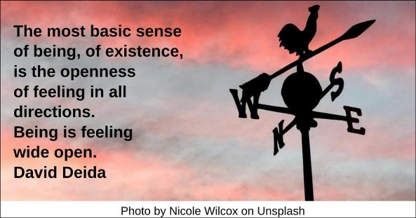

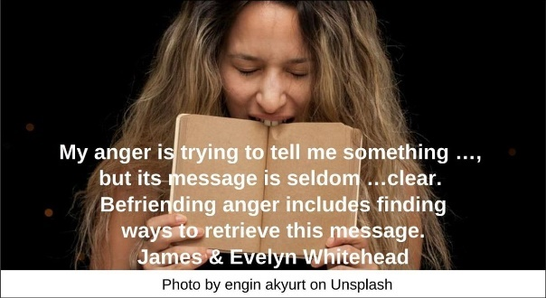

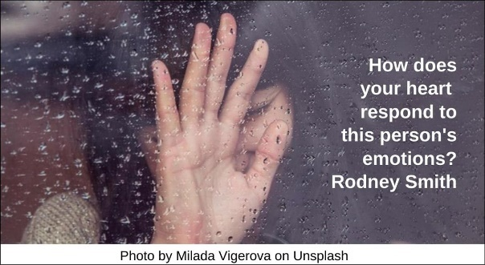



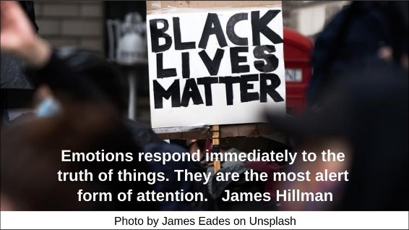

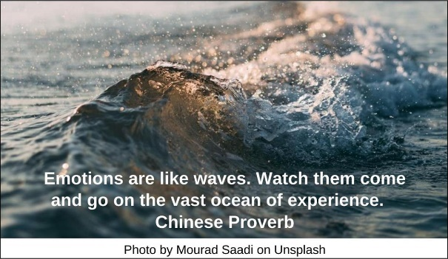

Resources for Children
2.0: Children’s Homilies, Sermons, Time for All Ages & Resources
2.1: Fair vs. Equal by Rev. Erika A. Hewitt (507 words)
What does “fair” mean? Is “fair” the same thing as “equal”? Which one is reflected in the concept of “justice”? Designed to be used as a Message for All Ages or as part of a Children’s Chapel service, this activity uses cookies (yum!) to explore the differences between fair and equal.
To prepare, you’ll need cookies or crackers (“regular” sized, not goldfish crackers or mini-cookies). You’ll also need two plates. Be sure to first read through this description carefully, as this activity requires “on the ground” thinking!
Today’s service/message is about fairness. What does it mean when something is unfair? Has anything unfair ever happened to you?
Invite people to share their comments and experiences, or simply ask for a show of hands as affirmation that they have been in an “unfair” situation.
Is “fair” the same thing as “equal”?
Listen to and moderate opinions about “fair” versus “equal.”
To help us see for ourselves whether “fair” and “equal” are the same thing, we’re going to use some volunteers and this bag of cookies [or crackers].
Explain as you go: Bring out 10 of the cookies/crackers and two plates.
Invite two volunteers, preferably children or youth of about the same age, to come forward. Give each of the children an empty plate. Narrate as you divide the 10 cookies/crackers equally between the two children’s plates. (Make sure that all of your volunteers know that the cookies are for demonstration purposes—no fair eating them until the service is over!)
Each of our volunteers has five cookies. Is that equal?
Confirm: ten divided by two = five cookies each.
Is it “fair” for each person to get five cookies? It might be. But let’s start asking our volunteers some questions.
Ask your two child volunteers what they had for breakfast, and it should be obvious whose breakfast was bigger.
Since X (name) had a bigger breakfast than Y (name), their breakfasts weren’t equal size. Don’t you think that it’s fair to give Y more cookies, to make up for their smaller breakfast?
Invite people to offer their opinions, thanking them for each opinion. As they make suggestions, you or the volunteers can shuffle the cookies back and forth on the two plates to reflect general consensus of what a “fair” distribution of the ten cookies looks like. If no one has already mentioned it, say:
Wait! Maybe one of our volunteers is hungrier than the other!
Determine – however whimsically, or just on a self-reported scale of one to ten, which child is hungrier than the other.
Since X (name) is hungrier than Y (name), isn’t it fair to give X more than half of the cookies, even though it’s not equal?
Again, solicit feedback about what a “fair” distribution of cookies is, based on hunger.
Send one of the volunteers back to their seat (big thank you from the group). Invite a volunteer of a much different age to come join the other volunteer. Each of them should still hold a plate.
Now we have people of different sizes to share the ten cookies. X (child’s name) is n years old. Z (adult’s name) is... well, older than that!
Since X is so much smaller than Z, is it fair to split the cookies evenly? Do you think that Z get more cookies because they’re bigger than X? Or should Z get fewer cookies because they’re a grown-up and can buy cookies anytime they want to?
Solicit opinions and move cookies from plate to plate, according to comments. Then:
You know, we haven’t even talked yet about what kind of cookies these are! Maybe we should find out whether X and Z even like gingersnaps (or lemon cookies, or fig newtons...)!
Ask your volunteers whether they like the cookies being offered.
If both volunteers report that they like the cookie type, send one volunteer back to their seat (with thanks). Ask for yet another volunteer: one who does not like the type of cookie being offered, or who is allergic to the type of cookie being offered.
Now we have a very different situation. Z really likes eating this type of cookie. But Q (dislikes/allergic) doesn’t want to eat any. What’s the fairest way to split the cookies now? Is it fair that Z gets all ten cookies just because they like (the gingersnaps), and Q doesn’t get any?
Ask people to suggest a “fair” re-distribution of the ten cookies, and move the cookies to the appropriate plate.
Thank both volunteers, taking the plates with cookies and inviting them to return to their seats with thankful “applause.”
What did we see, by bringing up different pairs of people and trying to split ten cookies between them? What are some factors that make something seem “fair”?
As you invite comments and discussion, narrow the conversation to the “moral” of this service:
It turns out that “equal” is not the same thing as “fair.” Equality is a good thing: when we talk about people being “equal,” or having “equal” rights, we mean that all people have the same giant amount of inherent worth and dignity.
As we saw, though, fairness is different. Fair doesn’t mean we get the same thing that everyone else has. Fair means that we go beyond what looks equal and instead ask a lot of questions. We’re beginning to see that fairness is complicated!
As Unitarian Universalists, we talk a lot about “justice.” When we use the word justice, often we’re talking about fairness. When we see something that’s unfair, we believe in saying so. And just like we had to talk about ways to divide up the cookies, sometimes we need to talk (...a lot) about how to make things fair. This can be complicated, but it’s a wonderful thing about Unitarian Universalism: we believe in equality AND in fairness, even when they’re different.
Source: https://www.uua.org/worship/words/activity/fair-vs-equal

3.0: Wisdom Stories
Anger
3.1: Mussa and Nagib (484 words)
Adapted from a story by Malba Tahan (pen name for Julio Cesar de Mello e Souza, 1895-1975), a mathematician from Brazil who also wrote The Man Who Counted (Editoria Record, 2001), which was first published in Brazil in 1949.
Once, two friends named Mussa and Nagib made a journey through the mountains of Persia on camel back. (Leader — If you have fashioned clay camels, you can start with the characters on camel back outside of the theater.)
They came after a time to a place where a stream flowed by a sandy bank and trees gave shade. (Leader — Walk the characters down to the river’s edge.)
There they had a discussion, which turned into an argument. Nagib grew angry, and for the first time ever, he slapped Mussa across the face. (Leader — You may wish to act this out with the characters explicitly or less so.)
Mussa was stunned. He felt angry. He wanted to slap Nagib back. But then he thought, “I cannot be too mad at my friend because I could have done the same thing. We are alike, and I care about him, and I don’t want to fight with him anymore.” So, he walked over to the trees instead and picked up a stick. (Leader — Show this with the character.) With the stick he wrote in the sand, “Today my best friend slapped me.” (Leader — Use the toothpick to write this in the sand for all to see.)
Then he and his friend stood in silence and watched as the desert wind blew the words in the sand away. (Leader — Blow the sand gently, until the writing disappears.)
By the time the writing had disappeared Nagib had said that he was sorry. The friends got back on their camels and rode to their destination in a distant city. On their trip back through the mountain pass they stopped again at the same river. (Leader — You can show this with the characters leaving the stage and then returning.)
This time the two friends decided to take a swim. Since their first visit, the rains had made the current stronger and river much deeper. Mussa, the friend who had been slapped, stepped into the water first. Right away, he slipped on a rock, was dragged under by the current, and began to drown. Nagib jumped in without a second thought and pulled his friend to safety. (Leader — Show these actions with the clay figures.)
The two friends again sat in silence for some time until Mussa had regained his breath. Then he rose and went to his saddlebags. There he found a carving knife. This time he went to a rock near the river. (Leader — Show the character moving off and back.)
Into the rock he carved these words, “Today my best friend saved me.” (Leader — Use the toothpick or other sharper object to write the words in the clay.)
Again, the two friends sat in silence. Finally, Nagib spoke, “My friend, after I hurt you, you wrote the words in sand. Now after I saved you, you wrote the words in stone, why?” (Leader — Demonstrate this dialogue, using the characters.)
Mussa replied, “When someone hurts us, we should write it down in sand where the winds of forgiveness can erase it away. This way our hearts are free from bitterness, and we can renew our friendships. But, when someone does something kind for us, we must engrave it in stone and in our hearts so that we will never forget.”
“Thank you my friend” said Nagib. “I am very grateful for our friendship. I don’t ever want to hurt you again.”
The two friends embraced and continued on their journey together. (Leader – Have the two characters embrace. You can have them continue their journey, if you made camels, or just say, “The End.”)
Source: https://www.uua.org/re/tapestry/children/tales/session5/123298.shtml

3.2: The Answer is in Your Hands, adapted from an Indian folk tale (580 words)
There was once a wise woman who lived by herself near a small village. Rumor had it that she could always accurately predict when the rains would come, or help heal a sick child with herbs, or calm angry neighbors and help them to resolve their fights and arguments. People came from all over the land to meet with her and seek her advice on matters both small and great. Her reputation was such that was said she was never wrong — not ever.
Some of the children of the village didn’t believe that it was possible to always be right. Surely, she could not know everything! They decided to test her knowledge. First, they asked her to answer questions about the planets, the animals, and the world. No matter how hard the questions, she always answered correctly.
The children were amazed at her knowledge and learning and most were ready to stop testing the wise woman. However, one boy was determined to prove that the old woman couldn’t know everything. Hatching a devious scheme, he told all of his friends to meet him at the woman’s home the following afternoon so he could prove she was a faker.
All through the next day he hunted for a bird. Finally, he caught a small songbird in a net. Holding it behind his back so no one could see what was in his hands, he walked triumphantly to the wise woman’s home. (storytelling tip: take a wooden or stuffed bird and holds it behind your back.)
“Old woman!” he called. “Come and show us how wise you are!”
The woman walked calmly to the door. “May I help you?” she simply asked.
“You say you know everything — prove it — what am I holding behind my back?” the young boy demanded.
The old woman thought for a moment. She could make out the faint sounds of a bird’s wings rustling. “I do not say I know everything — for that would be impossible,” she replied. “However, I do believe you are holding a bird in your hands.”
The boy was furious. How could the woman have possibly known he had a bird? Thinking quickly, he came up with a new scheme. He would ask the woman whether the bird was alive or dead. If the woman replied, “alive,” he would crush it with his hands and prove her wrong. If she answered, “dead,” on the other hand, he would pull the living bird from behind his back and allow it to fly away. Either way he would prove his point and the wise woman would be discredited.
“Very good,” he called. “It is a bird. But tell me, is the bird I am holding alive or dead?”
The wise woman paused for a long moment while the boy waited with anticipation for his opportunity to prove her wrong. Again, the woman spoke calmly, “The answer, my young friend, is in your hands. The answer is in your hands.”
The boy realized that the wise woman had once again spoken correctly and truthfully. The answer was indeed in his own hands. Feeling the bird feebly moving in his hands as it tried to escape his grasp, he felt suddenly very ashamed.
The answer was in his hands — slowly and gently he brought his hands to the front of his body. Looking into the eyes of the delicate bird he apologized, “I am sorry little one,” and he opened his hands to let her go free.
(Storyteller uses the sound instrument to signify that the story has ended.)
Source: https://www.uua.org/re/tapestry/children/tales/session11/story1

3.3: Anger A Buddhist Story by Sarah Conover (345 words)
From Kindness: A Treasury of Buddhist Wisdom for Children and Parents (Condra Enterprises, 2005).
One day, the Buddha and a large following of monks and nuns were passing through a village. The Buddha chose a large shade tree to sit beneath so the group could rest awhile out of the heat. He often chose times like these to teach, and so he began to speak. Soon, villagers heard about the visiting teacher and many gathered around to hear him.
One surly young man stood to the side, watching, as the crowd grew larger and larger. To him, it seemed that there were too many people traveling from the city to his village, and each had something to sell or teach. Impatient with the bulging crowd of monks and villagers, he shouted at the Buddha, “Go away! You just want to take advantage of us! You teachers come here to say a few pretty words and then ask for food and money!”
But the Buddha was unruffled by these insults. He remained calm, exuding a feeling of loving-kindness. He politely requested that the man come forward. Then he asked, “Young sir, if you purchased a lovely gift for someone, but that person did not accept the gift, to whom does the gift then belong?”
The odd question took the young man by surprise. “I guess the gift would still be mine because I was the one who bought it.”
“Exactly so,” replied the Buddha. “Now, you have just cursed me and been angry with me. But if I do not accept your curses, if I do not get insulted and angry in return, these curses will fall back upon you—the same as the gift returning to its owner.”
The young man clasped his hands together and slowly bowed to the Buddha. It was an acknowledgement that a valuable lesson had been learned. And so the Buddha concluded for all to hear, “As a mirror reflects an object, as a still lake reflects the sky: take care that what you speak or act is for good. For goodness will always cast back goodness and harm will always cast back harm.”
Source: https://www.uua.org/re/tapestry/children/loveguide/session12/anger

3.4: The Dervish in the Ditch (263 words)
Once upon a time, in a land to the east, a Dervish holy man and their student were walking from one village to the next. Suddenly they saw a great huge cloud of dust rising in the distance. They stood and stared at a grand carriage, pulled by six horses approaching at a full gallop. Riding on top were two liveries dressed in red, each holding a rein. The Dervish and the young student soon realized that the carriage was not going to slow down, let alone veer to the side to avoid hitting them. The carriage was coming at such a speed that they had to throw themselves from the road and jump into a ditch to save themselves. Covered with dirt and grass, the two got up. They looked after the carriage as it sped away into the distance.
The student was first to respond. They began to call out and curse the drivers. But the teacher ran ahead, cupped his hands over the student’s mouth, and called to the carriage: “May all of your deepest desires be satisfied!”
The student stared at the teacher and asked, “Why would you wish that their deepest desires be satisfied? They nearly killed us!”
The old Dervish replied, “Do you think all their deepest desires are satisfied? If they were happy, would they be so thoughtless and cruel as to nearly run down an old man and a student?”
The young student had no answer, for they were deep in thought. And so, in silence, the two continued their journey down the dusty road.
----------
This story is found in a number of sources, including From Once Upon a Time... Storytelling to Teach Character and Prevent Bullying by Elisa Davy Pearmain; Doorways to the Soul: 52 Wisdom Tales from Around the World, edited by Elisa Pearmain (Pilgrim Press, 1998); Buddha Is As Buddha Does by Surya Das (Harper One, 2008); and Milk from the Bull’s Horn: Tales of Nurturing Men by Doug Lipman (Yellow Moon Press, 1986).
Source: https://www.uua.org/re/tapestry/children/loveguide/session13/dervish-ditch

3.5: Ruby Bridges, Surrounded by Love by Janeen Grohsmeyer (718 words)
When Ruby Bridges was six years old and in the first grade, just like many other children, she went to a new school. Ruby’s school was called William Frantz Elementary School. It was in the City of New Orleans in the state of Louisiana.
And, just like other children, Ruby was nervous about the first day of school. She knew everything was going to be different: a new building, new teachers, new rules, new things to learn, new children to play with, and (she hoped) new friends.
But, unlike other children, Ruby didn’t go to school by walking or riding in her parents’ car or in a school bus. Ruby went to school in a police car, followed by people from her neighborhood to help keep her safe. Ruby walked to the front door of her school surrounded by four tall men who had guns and wore armbands with the words “U.S. Marshal” on their sleeves.
Because Ruby wasn’t just like the other children at William Frantz Elementary School. She was the only African American child in the entire school, and some people didn’t think she should be there.
You see, Ruby started first grade in 1960, about sixty years ago. Back then, in some parts of the United States, children with different skin colors went to different schools. There were schools for children with dark skin, and there with schools for children with light skin. That was called segregation.
Some people liked segregation, but many people knew it wasn’t fair. The schools for white children always had more books, better buildings, and lots more of everything than the schools for black children. Because of that, our government made a law that said all children—no matter what their skin color—can go to the same schools. That is called integration.
The parents at William Frantz Elementary School who liked segregation did not like integration. Because Ruby had dark skin, they thought she didn’t belong at the school. They kept their children home from school, away from her. Ruby was the only student in her class. She didn’t have anyone to play with or to talk to, except for her teacher, all day long.
And every day, those people who didn’t like integration would go to Ruby’s school, and they would yell horrible, mean things at her. Some called her names. One woman threatened to poison her. Sometimes they would even throw rocks or eggs or tomatoes, trying to keep her away from the school.
Yet every day, Ruby Bridges would go to that school. She would get dressed and eat breakfast and get ready for school, and then her mother would say, “I’m proud of you,” and her father would say, “You’re my brave little girl,” and they would all say, “I love you” to each other.
Every day, her neighbors would surround the police car that Ruby was riding in, and the four U.S. Marshals would surround her as she walked through that crowd of angry people, to help keep her safe.
And every day, Ruby would say a prayer—but not for herself. Ruby prayed for the angry people who yelled at her, asking God to forgive them and to change their minds. When Ruby Bridges was surrounded by hate, she surrounded everyone with love.
After a while, it worked.
The next year, when Ruby Bridges was seven years old and starting the second grade, the angry crowd of people wasn’t there. She didn’t have to ride in a police car. There were no U.S. Marshals surrounding her. White people did not keep their children home from William Frantz Elementary School, even though Ruby was there.
When Ruby went to her classroom on that first day of second grade, there were twenty other children. Some of them had dark skin, like her. Some of them would be her friends. Integration had happened, and William Frantz Elementary School was a school for all children.
Fifty years ago, Ruby Bridges helped to integrate a school, and integration helped make our country more fair for everyone. Today, Ruby Bridges is all grown-up, and she travels to schools all over the country, telling her story and teaching people to respect and appreciate each other.
Each of us can be like Ruby. We can all surround each other with love.
Source: https://www.uua.org/re/tapestry/children/lovesurrounds/session11/ruby-bridges-surrounded-love

3.6: The Stolen Soup Aroma, from the All Folk Tales website. (473 words)

Used with permission.
A long time ago in the village of Ipetumodu, there lived a poor woman. This woman was so poor that she did not have any soup for her eba. The eba is a starchy paste made from cassava flour and it is rather unappetizing to eat all by itself. Across the street from this poor woman lived another woman who cooked egusi soup every day. (Egusi soup contains protein rich egusi seeds, vegetables and sometimes meat.)
One day, as the poor woman was sitting down to her only meal for the entire day, a small bowl of eba, the aroma from her neighbors cooking wafted down through her window.
“Perhaps she will be kind enough to let me have a little soup for my eba” she thought. So, she took her bowl of eba and headed over to her neighbor who was busy stirring a big pot of egusi soup.
“Please, may I have a little soup for my eba?” the poor woman asked.
The woman stirring the egusi soup looked up to see her raggedy-looking neighbor and replied, “If you can’t make your own egusi soup, then you don’t deserve to have any.”
The poor woman went back to her own hut and sat outside her doorsteps where the aroma from her neighbor’s egusi was very strong. She would scoop some eba with her hands, inhale a big dose of egusi soup aroma while she swallowed the lump of eba.
The egusi woman, seeing this destitute neighbor eating her soup’s aroma got very angry. She ran out and yelled at the woman “Stop eating the aroma from my soup!” But the poor woman did not stop, she kept inhaling the aroma from the egusi soup while she ate her eba. She found the aroma from the soup very satisfying.
Every day, whenever the rich aroma of egusi soup wafted into the poor woman’s hut, she would quickly make a little bowl of eba and go outside to inhale the pleasant aroma. The egusi woman was getting very furious and she decided to take her case to the oba, the king of their village.
“This woman steals the aroma from my egusi to eat her eba. She must be punished,” the egusi woman told the oba. The oba heard the story and agreed that the poor woman should indeed be punished for stealing soup aroma and he ordered the egusi woman to carry out the punishment.
“She stole your aroma therefore you shall flog her shadow,” the oba told the egusi woman. “You shall flog her shadow forty times.” And she was given the big stick with which she would carry out her justice.
The egusi woman, wielding her big stick to beat the poor woman’s shadow felt very foolish. She felt so foolish that she asked the poor woman for forgiveness and offered to give her real egusi soup from that day on.
Source: https://www.uua.org/re/tapestry/youth/call/workshop7/172944.shtml

3.7: The Tennessee Valley Unitarian Universalist Church Shooting (473 words)
On July 27, 2008, people gathered in the sanctuary of the Tennessee Valley Unitarian Universalist Church in Knoxville to watch the children and youth of the congregation present the musical Annie Jr. Suddenly, a shot rang out. At first, many thought the noise was part of the musical, but they quickly realized there was a gunman in the sanctuary. Some people ran from the room, others threw themselves and their children under the pews. The gunman killed Greg McKendry when he moved in front of others to shield them from gunfire. The gunman wounded several other adults including Linda Kraeger, a visitor to the congregation, who later died of her wounds. People in the sanctuary tackled and subdued the gunman, who had concealed his shotgun in a guitar case as he entered the church. The police arrived and took into custody the shooter, David Adkisson. A witness said, “Everybody did exactly what they needed to do. There was very little panic, very little screaming or hysteria. It’s a remarkable congregation of people. I’ve never seen such a loving response to such an overwhelming tragedy.”
Adkisson, an Army veteran, had left a letter in his car expressing his frustration with being unemployed, and stating that he was motivated by hatred of liberals, democrats, African Americans, and homosexuals. He said in the letter that he had intended to continue shooting until the police came and killed him. The police affidavit reports that Adkisson later stated that, “he had targeted the church because of its liberal teachings and his belief that all liberals should be killed because they were ruining the country, and that he felt that the Democrats had tied his country’s hands in the war on terror and they had ruined every institution in America with the aid of major media outlets.” He further stated: “This isn’t a church, it’s a cult. They don’t even believe in God. They worship the God of secularism. The UU church is the fountainhead, the veritable wellspring of anti-American organizations.”
Press reports indicate that his former wife had at one time been a member of the church, but there is no evidence that Adkisson ever attended any events at the church. Nonetheless, he wrote, “They embrace every pervert that comes down the pike, but if they find out your [sic] a conservative, they absolutely hate you. I know. I experienced it.”
In early 2009, Adkisson pled guilty to two counts of murder and six counts of attempted murder and was sentenced to life in prison.
The Tennessee Valley Church was rededicated a few weeks after the shooting and a relief fund for those affected was created in the Southeast District and at the Unitarian Universalist Association. Just before Adkisson’s guilty plea in 2009, Tennessee Valley Unitarian Universalist Church named its fellowship hall for McKendry and its library for Kraeger.
Source: https://www.uua.org/re/tapestry/adults/ethics/workshop5/191874.shtml

3.8: Margaret Fuller’s Mystical Experience (1,311 words)
Based on multiple sources, particularly a letter from Margaret Fuller to Caroline Sturgis, October 22, 1840. The letter may be found at Houghton Library, Harvard University (call number MS Am 1221 (242)).
By the time Margaret Fuller was nine, she read literature in four languages, translated Virgil and Cicero, and wrote literary critiques of major European philosophic and literary texts. Each night, at the end of Margaret’s grueling day of scholarship, when her father returned home from work, he would enter her bedroom, awaken her by kissing her on the lips, then carry her to his study and make her recount what she had learned during the day. Reflecting on the years she endured this paternal, invasive abuse, Fuller said: “I did not go mad, as many would do, at being continually roused from my dreams. I had too much strength to be crushed, — and since I must put on the fetters, could not submit to let them impede my motions. My own world sank deep within, away from the surface of my life; in what I did and said I learned to have reference to other minds. But my true life was only the dearer that it was secluded and veiled over by a thick curtain of available intellect, and that coarse, but wearable stuff woven by the ages, — Common Sense.”
Fuller’s father made the nature and manner of his love for her very clear: It must be earned, as he repeatedly told her. He was tyrannical against his wife, Margaret Crane, for any infraction, and when away, threatened by letter, upon his return, to forcefully remind her of her place. Margaret read all of these letters and learned to conform to his absolute desires and expectations of her. When her younger sister died and her mother emotionally withdrew, Margaret became absolutely dependent upon her father for any show of affection. He was bitter, sarcastic, arrogant, snide and domineering. As an adult so, too, was she. But not all of her succumbed to her father, as she explained in a letter written in November 1832 to her friend James F. Clarke: “I have often told you I have two souls and they seem to roll over one another in the most incomprehensible way — All my tastes and wishes point one way and seem forced the other way.”
After her father died of cholera in 1835, Fuller undertook the grueling work of uniting her two souls: her male-trained intellect and her inmost personal feelings and intuitions as a woman. She wanted to become an intelligent woman, rather than a woman with a man’s mind. This union of mind and heart, body and intellect was hard won. To this end, she secluded herself away to mourn her father’s death and at the same time to find her own life. She found the point of contact for her sundered soul. She said she had discovered the divine within her. For her, it was at one and the same time a mystical experience and a transformation of herself into a human rights advocate. She described what happened in her October 22, 1840 letter to her dear friend Caroline Sturgis
... I can say very little now, scarce a word that is not absolutely drawn from me at the moment. I cannot plunge into myself enough. I cannot dedicate myself sufficiently. The life that flows in upon me from so many quarters is too beautiful to be checked. I would not check a single pulsation. It all ought to be; — if caused by any apparition of the Divine in me I could bless myself like the holy Mother. ... Oh Caroline, my soul swells with the future. The past, I know it not... All the souls I ever loved are holy to me, their voices sound more and more sweet yet oh for an hour of absolute silence, dedicated, enshrined in the bosom of the One.
Yet the cross, the symbol you have chosen seems indeed the one. Daily, hourly it is laid upon me. Tremulously I feel that a wound is yet to be given. ... Oh the prophetic dread and hope and pain and joy. My Caroline, I am not yet purified. Let the lonely Vestal watch the fire till it draws her to itself and consumes this mortal part. Truly you say I have not been what I am now yet it is only transformation, not alteration. The leaf became a stem, a bud, is now in flower. Winds of heaven, dews of night, circles of time, already ye make haste to convert this flower into dead-seeming seed — yet Caroline far fairer shall it bloom again...
[I]n my deep mysterious grottoes I feared no rebuff, I shrunk from no publicity, I could not pause yet ever I sobbed and wailed over my endless motion and foamed angrily to meet the storm-winds which kept me pure...
And then something absolutely amazing happened in the midst of Fuller’s account of her mystical experience. A past recollection rose to her thoughts with what she called “charm unspeakable.” Fuller then described this new thought: her experience a few years earlier, of a winter night she spent attending to a neighbor who had tuberculosis and was dying from the effects of a botched abortion. That experience had taken place shortly after her own father’s death. She recounted being... in the sick chamber of a wretched girl in the last stage of a consumption. It was said she had profaned her maiden state, and that the means she took to evade the consequences of her stain had destroyed her health and placed her on this bed of death. The room was full of poverty, base thoughts, and fragments of destiny. As I raised her dying head it rested against my bosom like a clod that should never have been taken from the valley. On my soul brooded a sadness of deepest calm ... I gazed into that abyss [termed guilt] lowest in humanity of crime for the sake of sensual pleasure[.] [M]y eye was steadfast, yet above me shone a star, pale, tearful, still it shone, it was mirrored from the very blackness of the yawning gulf. Through the shadows of that night ghost-like with step unlistened for, unheard assurance came to me. O, it has ever been thus, from the darkest comes my brightness, from Chaos depths my love. I returned with the morning star. No one was with me in the house. I unlocked the door [and] went into the silent room where but late before my human father dwelt. It was the first winter of my suffering health the musings and the vigils of the night had exhausted while exalting me. The cold rosy winter dawn and then the sun. I had forgotten to wind the clock the day marked itself. I lay there, I could not resolve to give myself food. The day was unintentionally a fast. Sacredest thoughts were upon it, and I comprehended the meaning of an ascetic life. The Angel that meets the pious monk beside the bed of pestilence and low vice, that dwells with him in the ruined hut of his macerated body, hovered sweet though distant before me also. At times I read the Bible at times [poet William] Wordsworth[.] I dwelt in the thoughtful solitudes of his Excursion I wandered like his white doe... The sunset of that day was the same which will shine on my last hour here below. — Winter is coming now. I rejoice in her bareness, her pure shroud, her judgment-announcing winds. These will help me to dedicate myself, all these Winter spirits will cradle my childhood with strange and mystic song. Oh Child, who would’st deem thee mine canst thou read what I cannot write. No only one soul is there that can lead me up to womanhood and baptize me to gentlest May. Is it not ready? I have strength to wait as a smooth bare tree forever, but ask no more my friends for leaves and flowers or a bird haunted bower.
Source: https://www.uua.org/re/tapestry/adults/movesus/workshop5/margaret-fuller

3.10: Amy by William F. Schulz (347 words)
Excerpted from the 2006 Berry Street Lecture.
When I was seven or eight years old, I lived across the street from a little dog named Amy. Every afternoon after my school let out, Amy and I would play together for an hour. One of Amy’s favorite games was a dancing game in which I held her two forepaws in my hands and we would dance around the yard. Sometimes Amy even put her paws in my lap to signal that she wanted to dance. But I noticed that after a few minutes Amy’s hind legs would get sore and she would pull her paws away. The first few times we played our dancing game, I dropped her paws the moment I sensed her discomfort and we went on to something else.
But one day I decided to hold on. The more Amy tugged, the tighter I held on until finally, when she yelped in agony, I let her go. But the next day I repeated my demonic game. It was fascinating to feel this little creature, so much less powerful than me, entirely at my mercy.
I was lucky that Amy was such a gentle dog for she had every right to have bitten me and when, after two or three days, I saw that my friend, who had previously scrambled eagerly toward me on first sight, now cowered at my approach, I realized with a start what I had done and I was deeply frightened of myself and much ashamed. Whatever had come over me that I would treat someone I had loved that way?
What had come over me, I now know in retrospect, was the displacement of anger onto one who held no threat to me. Bullies at school might pick on me. My two parents might tell their only child what he could and could not do. My piano teacher might try to slam the keyboard cover on my fingers when I played off key. But in that yard, I ruled supreme. Not only did I hold the power but the one who was powerless for a change was Not-Me.
Source: https://www.uua.org/re/tapestry/adults/movesus/workshop9/amy

Fear

3.11: A Private History of Awe (220 words)
Excerpted and adapted from Scott Russell Sanders’ book, A Private History of Awe (New York, North Point Press, 2006).
In his book A Private History of Awe, Scott Russell Sanders remembers a spring day when he was a young boy, old enough to run around and small enough to be carried in his father’s arms. The wind was booming; lightning flashed everywhere as a heavy rain fell. His father carried him out on to the porch, held him against his chest, and hummed as the thunder rumbled. They looked out at the trees and the huge oak which was the tallest thing the child knew. The oak swayed in the storm. Suddenly a flash and boom split the air. Everything became a white glare. “Sweet Jesus,” his father cried out, grabbing him and pulling him close. Lighting had struck the oak and it snapped like a stick. Its top shattered onto the ground and a charred streak ran down the trunk.
One moment the great tree was there as solid as the father, bigger than anything Scott knew, and the next moment it was gone.
Fifty years later that day still haunts Scott. That was the day when power, energy, wildness that surges through everything was revealed in a flash. Scott writes, “The sky cracked open to reveal a world where even grownups were tiny and houses were toys and wood and skin and everything was made of light.”
Source: https://www.uua.org/re/tapestry/adults/life/workshop4/159225.shtml

3.12: Life of an Ally (795 words)
Juliette Hampton Morgan was the only child of Frank and Lila Morgan of Montgomery, Alabama. Her white skin and family pedigree gave her entrance to the finest shops, restaurants, galleries and concert halls. For much of Juliette’s life, her privilege meant someone else did her laundry, cooked her meals and did her yard work. She was a public-school teacher, a librarian in Montgomery’s Carnegie Library and later served as the director of research at the Montgomery Public Library. These were acceptable positions for a white woman in society to hold. However, some of Juliette’s activities outside of work were not as acceptable. She belonged to an interracial prayer group. The group had to meet in black churches because no white church would welcome them. Many of Juliette’s friends and family members did not understand her desire to belong to this group.
One seemingly insignificant thing about Juliette’s life separated her further from her privileged friends: she had severe anxiety attacks. These attacks prevented her from driving her own car so, to get to work, she rode the city buses in Montgomery. On those buses, she saw white bus drivers “use the tone and manners of mule drivers in their treatment of Negro passengers.” She watched them threaten and humiliate black men and women who paid the same 10-cent fare she paid. They threw their change on the floor, called them derogatory names, and left them standing at bus stops in the rain.
One morning as she rode the bus, Juliette watched a black woman pay her fare and then leave the front door of the bus to re-enter through the back door, as was the custom. As soon as the black woman stepped off, the white bus driver pulled away, leaving the woman behind even though she’d already paid her fare. Incensed, Juliette jumped up and pulled the emergency cord. She demanded the bus driver open the door and let the black woman come on board. No one on the bus, black or white, could believe what they were seeing. In the days that followed, Juliette pulled the emergency cord every time she witnessed such injustices.
News spread quickly, and bus drivers began to bait Juliette, angering her so she would get off the bus and walk the rest of the way to her destination, sometimes a mile or more. White passengers would mock her as she got off the bus. Her own mother told her she was making a fool of herself and tarnishing the family’s good name.
In 1939—16 years before the famous 1955 Montgomery Bus Boycott—Juliette began writing letters to local newspapers denouncing the horrible injustices she witnessed on the city buses. Her last letter was published in 1957 in the Tuscaloosa News in which she thanked the newspaper’s editor for his opposition to a local council of white men that he believed—and Juliette agreed—was contributing to continued racial violence. “I had begun to wonder,” she wrote, “if there were any men in the state — any white men — with any sane evaluation of our situation here in the middle of the Twentieth Century, with any good will, and most especially with any moral courage to express it.”
During her years of letter writing, Juliette was bombarded by obscene phone calls and hate mail. White people boycotted the library where she worked. They called her an extremist. Teenage boys taunted and humiliated her in public and in front of her staff at the library. Juliette’s personal campaign against racism and injustice caused her to become estranged from friends, colleagues, neighbors and even her own mother.
Powerful white men and women in Montgomery demanded that Juliette be fired. The burned their library cards and boycotted the library. The library superintendent and trustees refused. The mayor withheld municipal funding to the library, in an effort to force the library to cut Juliette’s position. On July 15, 1957, a cross was burned on her lawn. Juliette resigned from the library the next day and committed suicide that night, leaving a note that read simply, “I am not going to cause any more trouble to anybody.”
Reverend Martin Luther King, Jr, in his book, Stride Toward Freedom, remembered Juliette and gave her credit for first comparing the Montgomery bus boycott to Gandhi’s work in India. In 2005, Juliette Hampton Morgan was inducted into the Alabama Women’s Hall of Fame. Later that year, the Montgomery City Council voted to rename the main public library after her. Juliette’s actions and her words are as relevant today as they were when she was alive: “There are thousands who want to change our old order, but they are afraid of speaking out. I believe that it is our biggest problem—overcoming the fear of decent white people.”
Source: https://www.uua.org/re/tapestry/youth/call/workshop5/172096.shtml

3.13: Hosea Ballou’s Conversion (577 words)
In 1789, Hosea Ballou attended the Baptist revival held in his hometown of Richmond, New Hampshire. Moved by the preaching during this event, which was touted as “The Great Reformation,” Ballou, age 19, stepped forward to be baptized. Like his friends and the hundred or so others around him who also stepped forward to be saved, Ballou had been gripped by fear. But unlike the others professing their new, aching need for God’s forgiveness and grace, Ballou was not fearful enough. He did not feel what he was supposed to feel: gut-wrenching fear. He believed the dominant Calvinist theology of his era which claimed God separated the elect from the damned before they were born and that except for these chosen few, all were doomed to eternal damnation, fire and brimstone for their sins. Yet, he did not feel clenched in the grip of an angry, vengeful, wrath-filled God described by the two preachers who led the revival. Ballou was upset because he wasn’t upset enough. People were supposed to be terrified of this God and fearful that they might not be one of His chosen people.
Ballou described his predicament years later, in a letter to a friend: “I was much troubled in my mind because I thought I did not stand in such fear of the divine wrath as I ought to do, or as others had done before they found acceptance with God.” Worse yet, the doctrines he was now supposed to believe about God and Christ rung hollow.
To figure out what was going on, Ballou turned to the Bible to make sense of the doctrines of his newly professed faith. His mind became troubled anew. It seemed to him that nothing in the Bible supported belief in the Baptist doctrines he was supposed to espouse: belief in eternal damnation for all human beings except a preordained “elect” few; belief in the sacrifice of Christ to reconcile an aggrieved God to sinful man; belief that Christ as the Son of God was also, at the same time, his own Father. Ballou’s keenly rational mind rejected such notions as illogical and thus patently absurd. The Bible seemed to affirm Universalism—universal salvation for all—and Unitarianism—the unity of the Godhead rather than in a Triune God as Father, Son, and Holy Ghost.
With these discoveries, Ballou felt happy. Happiness abounded in his heart. And he now knew why he had not felt fearful enough: There was nothing to fear. The God of wrath preached by angry ministers was a human-made God, a false God. By removing the false teachings and the errant theology, Ballou felt the God of love. Ballou felt loved and he was happy. But when Ballou tried to explain to local ministers what he felt and what he had discovered, they screamed at him about his burgeoning Universalist faith, rather than reason with him over the interpretation of biblical texts. So Ballou’s Universalism and Unitarianism took firmer hold of his heart and his mind and his new, liberal faith now flowed forth from happiness. He believed that all human beings would be blessed in their afterlife. God condemns no one to eternal punishment and damnation. Universal salvation, Ballou discovered, is a grace-filled gift of an eternally loving God for humanity.
Ballou finally believed that our personal desires motivate our actions and all of them (benevolence, greed, self-sacrifice, love, etc.) boil down to one: the personal desire to feel internally happy.
Source: https://www.uua.org/re/tapestry/adults/movesus/workshop3/282532.shtml

Sadness
No stories identified.

Happiness

3.14: How Coyote Lost His Songs, Music, And Dance by Rev. Kenneth W. Collier (1,330 words)
From Our Seven Principles in Story and Verse: A Collection for Children and Adults by Kenneth Collier (Boston: Skinner House Books, 1997). Used with permission.
Here is a new story about Coyote. One day it occurred to him that he didn’t need any of the other creatures. There he was, sitting pretty all by himself. What did he need anyone else for? He had his songs, his flute and drum, and his fire. He had his dancing and his huge tipi. Besides, all the other creatures were kind of strange. There was Rabbit, with his huge ears and enormous legs, and all he ever did was run around. And there was Moose, with that absurd head of antlers, wandering up to his knees in marshes. And there were all these pesky birds, flitting around, twittering, and never letting Coyote nap. Ridiculous! Who needed them? Not Coyote!
So, he decided to just leave them all behind. He picked himself up and wandered off, trying to find a place where he could be alone. Entirely alone, with none of these silly and absurd creatures to bother him, where he could dance his dances by himself and sing and play his flute and drum for no one but himself, a place where he wouldn’t have to share his fire and he could nap in peace.
As Coyote was leaving, Rabbit happened to see him and tagged along. At first he ran ahead with his big legs and then he ran back, and then ahead, and then back. Coyote ignored him, hoping he would just go away.
“Hey, Coyote,” Rabbit yelled. “Where ya goin’?”
Coyote ignored him.
Rabbit ran on ahead and came back. “Hey, Coyote,” he said. “Know what’s on the other side of that hill? I do. I just saw it.”
Coyote was curious, but he ignored Rabbit and just kept on walking. Rabbit ran on ahead and came back.
“Hey, Coyote,” he said. “There’s something over there, where you’re headed, and you ought to know about it. I just saw it. Want me to tell you about it?”
Well, Coyote did want to know, but he just ignored Rabbit, hoping he’d go away and leave him alone. Ridiculous Rabbit.
Rabbit’s feelings were a bit hurt. “Coyote, you know what? You’re crazy.” And he went away.
That night, a funny thing happened. Coyote stopped and built his fire and sat down to sing, as he did every night. But as hard as he tried, he couldn’t remember any of his songs. And so all he could do was play his flute and drum, and dance a little. But he couldn’t sing. And the night was strangely quiet.
The next day, Coyote was off again, feeling a little sad and a little strange. But he still wanted to get away from these ridiculous creatures with their absurd ways of being. Before long, he came to a marsh. It was so wide he didn’t see how he could go around it, and, shrugging his shoulders, he started to go through it. Pretty soon he ran into Moose, who was as usual up to his knees in mud and weeds. Moose lifted his huge head of antlers when he saw Coyote coming. “Well, hello Coyote,” he said. “What brings you way out here to the marshes?”
Coyote ignored him and kept looking for a way to cross the mud. Moose swung his great head this way and that, a little miffed that Coyote was ignoring him.
“Coyote, if you’re looking for a dry path, I could help you,” he said.
Coyote looked right at him and said nothing. What a ridiculous creature, Coyote thought to himself. lf I had such silly things growing out of my head, I wouldn’t let anyone see them!
Moose’s feelings really were hurt by now. “You know what, Coyote? You’re crazy!” And Moose walked away.
Coyote finally did find his way across the marsh and went on. That night something strange happened. Again, Coyote built his fire and tried to make his music, but not only had he forgotten his songs, now he couldn’t remember how to play his flute and drum. All he could do was dance around the fire. And the night was frighteningly silent.
The next day, Coyote was really upset and a little afraid, but he had decided that he would get away from all these silly creatures, and get away he would. So he set off again. This time, he came to a little stream that flowed down out of the mountains. All along its banks were bushes and flowers and it was beautiful and still and cool. And since he was thirsty and a little tired, Coyote took a long drink, sat down, and decided to take a nap.
As they often are, the bushes were filled with birds, and just as Coyote was about to go to sleep, the little birds started singing their songs. This was exactly what he wanted to get away from. It really made him angry that the birds wouldn’t let him sleep in peace. And he was a little afraid and jealous that they could sing and he had forgotten his songs and even how to sing. And so, he leaped up and snarled and barked at them to frighten them away.
And he succeeded. They flew up and off. But one bird, a little braver than the others, said to him — being careful to fly just out of his reach — “Coyote, you’re crazy!” And off she went.
Coyote was kind of pleased with himself for getting rid of the birds and so he decided to stay right there. That night he made his fire, but the strangest thing happened. Not only could he no longer sing, and not only could he no longer play his flute and drum, but now he couldn’t even remember how to dance! All Coyote could do was stare into the silent fire and think about how much he had lost.
Finally, he fell asleep and dreamed. In his dream, White Buffalo Woman appeared to him and asked him why he was so sad and scared. Coyote explained how he had lost his songs and music and dance. He didn’t know what to do, and he was afraid that he would also lose his fire.
White Buffalo Woman asked him why he was out here all alone. Coyote explained that he was tired of being surrounded all the time by those silly creatures who looked strange and acted strange and lived such ridiculous lives, and he had decided that he would live by himself, away from them all.
“Coyote,” said White Buffalo Woman, “don’t you understand that your music and your dance, and even your fire, are nothing but the spirits of those creatures who are different from you? As you drove them away, they left even your heart and took their spirits with them. If you want your music and dance back, you must go back to your friends and accept them back into your heart. Only then will you be able to go on.”
The next morning when Coyote awoke, he couldn’t remember his dream, but when the birds began to sing, as they always do in the morning, he sat still and listened to them. And then he began to go back the way he had come. That night when he built his fire, he could remember his dance. And the next day he went on, back the way he had come, and chanced upon Moose. And he asked Moose how to get across the marsh.
That night, when he built his fire, he remembered how to play his flute and drum and the night was not so lonely. And the next day he still went back the way he had come, and suddenly up ran Rabbit. Coyote ran with Rabbit and played and had a good old time. And that night, when he had built his fire, the air was filled with Coyote’s songs. And never again did Coyote forget how easily he could lose his music and his dance and even his fire.
Source: https://www.uua.org/re/tapestry/children/welcome/session6/118305.shtml

3.15: The Sword of Wood, A Jewish tale from Afghanistan (1,138 words)
Once, on a summer night in the country Afghanistan, the ruler Shah Abbis changed out of his fancy robes and left his palace dressed as a peasant to enjoy the evening air and to wander through the streets unnoticed. He walked and walked until he reached the poorest section at the edge of the town. He soon heard joyful singing coming from a dimly lit cottage. As he peered in the window, he saw a man sitting at a table. He was eating and singing and giving thanks to God. The shah was astonished to see such a poor man in such good spirits and so he asked if he might come in as a guest.
After accepting food and drink the shah asked the man how he earned his living. “I am a poor Jew,” he said. “I wander the streets and fix shoes, and in this way, I earn enough money to buy all the food I need for one day.”
“But what will happen to you when you are too old to work?” asked the shah.
“Oh, I do not have to worry about that,” the man said happily. “God blesses me day by day, and I know that somehow there will always be enough.”
The shah returned to his palace and took off his peasant disguise. He was determined to test the faith of this man. The next day he proclaimed: “No one is allowed to fix shoes for pay!”
When the Jew went to work, he was astonished to learn of the new law. “What is he going to do if he can’t fix shoes and earn money?” (Take a few brief suggestions.)
Here’s what he did. He lifted his eyes to heaven (Leader — Raise your arms in the air and look up) and he prayed, “God, the Shah has made it against the law for me to fix shoes. But I know you will help me to find a new job.” He looked around and saw some people carrying water. He decided that he too would become a water carrier.
The Jew carried water to and from the town well and sold it to people, for the rest of the day. And in that way, he earned just enough money to buy food ... for one day. (Leader — You may wish to start the children at this point repeating the refrain, “to buy food for one day,” each time you say, “he earned just enough money ... “)
The shah again disguised himself and returned to the man’s house. He was very surprised to find the man again singing joyfully and eating. “How are you?” he asked upon entering. “I heard of the law and had to see how you had survived the day.”
“God did not abandon me today,” the Jew answered happily. “The shah closed one door, but God opened another to take its place. I am now a water carrier.”
The shah took his leave again. (Leader — “And what do you think he did?” After brief answers, continue the story.) He issued another proclamation: no one was to carry water for pay. Again, the Jew wondered how he could earn money if it was against the law to carry water. But again, he prayed and this time he saw that men were going into the forest to cut trees to sell for firewood. So, he decided to cut trees and sell firewood also, and that’s just what he did. And in that way, he earned just enough money... “ (Leader — Prompt the children to finish your sentence.) “... to buy food for one day.”
Again, the shah came in disguise and learned of the man’s continued faith and good fortune. The next day, he issued a command that his soldiers stop all the woodcutters coming from the forests and bring them to the palace to work. He dressed them all as guards and gave them swords. He told them that they would not be paid until the end of the month.
(Leader — “What will happen if the Jew is not paid until the end of the month? What do you suppose he should do?” After some answers, continue the story.)
The Jew was perplexed indeed, for he had no money for dinner that evening, and it would certainly be difficult to wait a whole month for his pay. But he trusted God. So, he prayed and he prayed for an answer to his problem. How would he be able to buy food tomorrow, if he wouldn’t be paid for a full month?
On the way home from the palace, while examining his sword and sheath, the Jew had a clever idea. He would make a sword out of wood, the same size as the shah’s metal sword that would look just like it. Then he could sell the shah’s sword. So, he made a wooden sword and sold the real one and he had just enough money for food for a month!
The shah, in his peasant disguise again, was much surprised to find the Jew singing and eating that night. When he heard the Jew’s story about the sword, he asked him, “What will you do if the shah finds out what you have done?”
“Oh, I do not worry about such things,” the Jew replied. “Every day my life is filled with blessings from God. I know that somehow everything will come out all right.”
The next day the shah ordered all the guards to report to the center of the city where there was to be an execution of a man who had stolen from the royal palace. All the guards came, including the ones who used to be woodcutters, and including the Jew. All the townspeople came to see.
The shah ordered his officer to call the Jew to come forth to cut off the man’s head. “Do not ask this of me,” the Jew cried. “I have never even killed a fly.” The officer said that it was the order of the shah and he must obey or risk his own life.
The Jew asked for a few minutes to pray to God. Then he stood up (Leader — Stand up and speak dramatically) in front of all of the townspeople and said out loud, “God, you know that I have never killed anyone in my whole life. Please, God, if this man is guilty, let my sword be so sharp as to kill him in a single blow. But if he is not guilty, let my sword turn to wood, as a sign of his innocence.” (Leader — Look at the children and ask them to predict what will happen. When they clearly understand what is going to happen with the sword and why, resume telling the story.)
With all eyes on him, the Jew reached for his sword. (Leader — Acts this out) He pulled it out of its sheath, and held it high. The crowd gasped, then clapped and cheered when they saw the wooden sword, for they thought a miracle had taken place.
The shah was delighted when he saw the wisdom of the Jew. He called him near. He told him that he had been the visitor those four preceding nights. “And now,” he said, “I hope that you will come and stay with me in my palace and be my advisor, for I see that you are a man of wisdom and unwavering faith, and I have much to learn from you.”
So, the Jew went to live in the palace with the shah. If you went by there in the evenings, you would hear them singing.
Source: https://www.uua.org/re/tapestry/children/tales/session3/story-1

3.16: The Stonecutter, based on a wisdom tale of Japanese origin (585 words)
Once upon a time, there was a stonecutter. He spent his life cutting up rocks for use in this and that and the other. He liked his work. He was a happy man. At least he thought he was, until one day he was cutting stone for the house of a rich family.
“Wow!” said the stonecutter. “Look at that palace! That’s for me. I want to be fat-cat rich and have a house like that and be happy!” He sighed a deep, unhappy sigh.
Suddenly a mighty voice thundered through the air. “That’s what you want, that’s what you get,” it said. “So shall it be.”
“This is the life,” said the rich man who once was a stonecutter as he looked out from his mansion. “How could life get better than this?”
But one day he had an answer. Out walking in the hot sun, he saw a prince ride by in a royal carriage. “Cool,” said the rich man. “It’s miserable out here in the sun, but I could be happy in that.”
A mighty voice thundered through the air. “That’s what you want, that’s what you get,” it said. “So shall it be.”
But the carriage was not all that cool, found the prince who once was a stonecutter and rich man. The sun still burned his face from time to time. “I know the fix for that,” said the prince. “I want to be the sun so I can do the burning.” A mighty voice thundered through the air. “That’s what you want, that’s what you get,” it said. “So shall it be.”
“Hot stuff!” said the sun who once was a stonecutter and a rich man and a prince, and he smiled a great big smile. Until a cloud came along and blotted him out. “Hey,” he said. “The cloud has a more interesting life than the sun. Look at it bouncing around in the sky raining and snowing whenever it likes. I want to be a cloud!”
A mighty voice thundered through the air. “That’s what you want, that’s what you get,” it said. “So shall it be.”
“This is the life,” said the cloud who once was a stonecutter, a rich man, a prince and the sun. “I guess I’ll go cause a flood.” Which he did. Rivers overflowed, and crops disappeared. But stones did not. Stones stayed right where they were. “The stone is stronger than I am!” cried the cloud. “I want to be a stone.”
A mighty voice thundered through the air. “That’s what you want, that’s what you get,” it said. “So shall it be.”
“At last,” said the stone who once was a stonecutter, a rich man, a prince, the sun and a cloud. “I’m the mightiest thing on earth. Nothing can destroy me!”
Then “WHAM!” And “WHAM” again. “Oh no,” said the stone who once was a stonecutter, a rich man, a prince, the sun and a cloud. “I am under attack! By a man with a chisel! He is mightier than the stone. I want to be him!”
A mighty voice thundered through the air. “That’s what you want, that’s what you get,” it said. “So shall it be.”
And so it was. The man who once was a stonecutter and a rich man and a prince and the sun and a cloud and a stone was a stonecutter again. And happy again. So happy, in fact, that he never again wished to be anything other than what he was.
Source: https://www.uua.org/re/tapestry/children/riddle/session12/stonecutter

3.17: The Mish-Mash Heart (438 words)
Recently at a multigenerational event at a Unitarian Universalist congregation, everyone was encouraged to create a heart. They were given some construction paper and some glue and some markers to design their heart. Emily worked diligently to create the most perfect, beautiful heart she could. It even had glitter in the shape of diamonds all around the outside.
As she was helping to clean up, she noticed the heart of one woman who was around the same age as her grandmother sitting at a nearby table. It was a mish-mash mess of odd colors and had pieces which were ripped and torn glued haphazardly upon it. Parts of it were wrinkled and crinkled and there was even a little hole in it!
Thinking there was something wrong, Emily offered to help the woman fix her heart. But the woman merely smiled and explained that there was nothing wrong with her heart; it merely revealed all the things which had happened to her in her life. She said there were happy times here: the beautiful colors and designs represented when she first met her husband, their wedding and the birth of each of their three children. There were other beautiful parts, too, which stood for watching her children taking their first steps on their own, riding a bike for the first time and graduating from college.
“But what about all the rips and tears and wrinkles?” Emily asked. “Why are they there?”
These were for the sad times in her life, the woman explained. The time her best friend was stricken with measles, the time someone lied or did something to hurt her feelings and the hole was left when her husband died. “In fact, every time a person comes into my life that I care about,” she explained, “they take a piece of my heart with them.”
This was distressing to Emily, thinking of the woman having to give part of her heart away to others. “But what happens if you give it all away?” she asked. “You’ll be left with nothing.”
“No, I won’t,” the woman responded with a smile. “Because you see, they give me a piece of theirs as well.”
Emily looked down at her beautiful, perfect heart with the glitter and the designs she worked so hard to make. Then she looked again at the woman’s mish-mashed heart with the jagged colors, rips and wrinkles. Without hesitation, Emily ripped a piece off of her perfect heart and handed it to the woman.
“Thank you,” the woman said as she placed it with her mish-mash heart and tore off a piece to hand to Emily.
Source: https://www.uua.org/re/tapestry/children/loveconnects/session3/161723.shtml

3.18: Clowning for Joy in Haiti by Sarah Foster (852 words)
Sarah Foster is a lifelong Unitarian Universalist who wanted to make the world a better place while doing something that she loved. What she loved was performing and making others laugh, so she became a clown. As a professional clown with Clowns Without Borders, Sarah has traveled to Haiti, Swaziland and South Africa. Clowns Without Borders sends professional clowns to areas of the world with children who have experienced more conflict and injustice than any child should have to endure. “Laughter is a critical way to heal trauma,” Sarah said. “Kids need to laugh and play. And all kids deserve joy. All kids. Everywhere.”
Friday, August 21, 2009: Sarah’s Journal (852 words)
To get to our first show of the day, we are to parade for half an hour up an enormous hill. When we climb out of the car and into the heat of the sun at the bottom of the hill, a group of kids starts to form around us. I look at them, look away, and quickly look back again with wide eyes. They smile. I do it again and they laugh. I walk with a funny walk around to the back of the car and the women across the street laugh. They watch me put together my trombone, piece by piece. Tim hangs his battered bucket drum around his neck. Suzanne has the bubble-making bear. The rest of our gear goes up ahead us of in the car. We are off!
Today, we are going into Martissant, one of the most dangerous areas of Port-au-Prince, Haiti, rated by the UN as a “red zone” because of the lack of control their peace-keeping troops have here. As Tim noted, over 100,000 people live in houses made of cement blocks, tarps and rusty tin stacked up the hill as high as we can see.
In town there are two water pumps — two. Two pumps for over 100,000 people. When we got into the region, we saw children playing all around the streets. In their hands were no toys, but water jugs. Each child had a water jug proportionate to his or her size and it was clear that people here rely on these children to do work and carry water for themselves and their families. A trek to the public wells is no simple task. We hardly encountered any level ground in all of Martissant—the community is nothing but steep hills dropping to sea level.
The high levels of poverty and violence here make it feel more important than ever that we do a fantastic show today: mainly because the kids here deserve a bang-up, hands-down hilarious show. Also, because, although we do not feel in immediate danger, making people laugh keeps potential violence at bay.
Kids pile around us as we parade up the hill. They pop out of doorways and join the crowd. Some women dance to the music as we go by. When I dance, they laugh. It seems important to look people in the eye and greet them as we go by, so that they feel a personal connection beyond just seeing a ragtag troop of weird sweaty white people parading past. I alternate between playing the trombone, greeting people, dancing, singing, and catching my breath. We are climbing the hot hill in a tide of kids now. They attach themselves, holding onto my elbows and the sides and back of my skirt. I feel like I am half pulling a pile of kids up a giant hill, half being supported up the hill by them.
“Ou bouke? (oo boo-kay)” says the girl who has attached herself to my right elbow. I just learned this creole word yesterday. One of the most common graffiti phrases on the walls of Port-au-Prince is “NOU BOUKE (new boo-kay).” It means “we are exhausted,” or “we are fed up.” When the words are spray-painted on walls it means that Haitian people are fed up with the way things are, with their ineffective government, with the lack of food and water. When this girl says “ou bouke? (oo boo-kay)” she is asking me if I am tired from the climb. “Mwen bouke! (mwe-ge {like the end of gara-ge} boo-kay)” I say, wiping the sweat from my face and pretending to lean on a little boy’s head for support. Then I take a deep breath and look around. “No, m’pa bouke (mmpah boo-kay)” (I am not tired), I say. “Nou bouke? (new boo-kay)” (are you all tired?) “No!” they say. “Nou pa bouke! (new pa boo-kay)” (we are not tired!) I say. “Nou pa bouke! (new pa boo-kay)” they reply. We keep climbing. I start a new trombone riff to the beat of Tim’s bucket drum.
More and more kids join in as we climb our way up. “Bon jou,” I greet them. “Bon jou!” they reply to the beat of Tim’s drum. Again, in rhythm, “bon jou!” I say, and “bon jou” they reply.
“Bon swa!” I say, which is the greeting for the afternoon and evening, and the wrong one to say for the morning.
“Bon swa!”
“No, bon jou!” I shout.
“Bon swa!” they say.
“Bon swa?”
“Bon jou!”
“Cuckoo!”
“Cuckoo!”
“Whoohoo!”
“Whoohoo!”
We continue this absurd call and response chant for a while, then more music and more dancing, all the while climbing. One of brightest rays of hope that I see in this country where so much is wrong is the way that people are so ready to laugh and to play. So, so often the joy is there, right under the surface. The smallest hint of a game becomes a massive game. Three clowns and a bucket and bubbles and a trombone becomes a parade. Women dance in the street.
Maybe a lot of people in Haiti are bouke a lot of the time. But right now, we are on our way up a hill to a show, and despite all odds we are not bouke at all.
Source: https://www.uua.org/re/tapestry/youth/call/workshop10/173071.shtml

3.19: Lizard’s Song (459 words)
Adapted from a National Park Service website; used by permission of Wind Cave National Park.
In this Native American legend, Lizard sings a happy song about his home: “Zole, zole, zole, zole, zole, zole, rock is my home.” Bear wants to learn the song. Lizard shares the song, but Bear keeps forgetting it. Bear insists again and again that Lizard re-teach her the song. Finally, Lizard tells Bear that the reason she can’t remember the song is that “rock” is not her home, “den” is her home. Bear goes off singing the adapted song, which she doesn’t forget.
For the tune to Lizard’s song, you may use “Mary Had a Little Lamb.” Change the last line from “rock is my home” to “den is my home” for Bear’s song. Before you begin reading or telling the story, invite the group to join in when you sing:
“Zole, zole, zole, rock (den) is my home.”
Note: Zole is pronounced “zoh/lee.”
Lizard’s Song (459 words)
There was a lizard who lived on a rock. He was very happy living on his rock. All day long Lizard would sing “Zole, zole, zole, rock is my home. Zole, zole, zole, rock is my home.”
One day a bear saw him sitting on the rock and heard him singing. She wondered why the lizard was so happy. So, she asked him, “Why are you so happy?”
Lizard said that he was happy because he was at home and the rock was a great place to live. “Oh,” said Bear. She went back to her home and thought “I wish I knew that song, so I would be as happy as the lizard.”
The next day, Bear went back to Lizard’s rock. She asked Lizard to teach her the song. Lizard said he would be very happy to teach it to her. He sang “Zole, zole, zole, rock is my home, zole, zole, zole, rock is my home.” That made Bear feel good again. She went home. But on the way, she forgot the song.
The next day, she went back to Lizard and asked him if he would teach her the song again. Lizard said he would be very happy to teach the song again. He sang “Zole, zole, zole, rock is my home, zole, zole, zole, rock is my home.” Again Bear went home, and again she forgot the song.
So, she went back to Lizard one more time. This time, Lizard was asleep on his warm rock in the sunshine. What could Bear do? She decided to pick Lizard up and put him in a bag. Then she could take Lizard to her home. After his nap, he could teach Bear his song.
On the way, Lizard woke up. He did not know where he was. He knew he wasn’t at home, on his rock. He was very scared. He didn’t know what to do. He decided to sing his song so he wouldn’t be so frightened. He sang “Zole, zole, zole, rock is my home, zole, zole, zole, rock is my home.”
When Bear got home, she opened the bag. “Where are we?” asked Lizard.
“This is my home,” said Bear. “I’m sorry if I scared you when I brought you here.”
Now Lizard saw that Bear didn’t live on a rock. Now he understood why Bear couldn’t learn the song. He told Bear that she couldn’t learn the song because she didn’t live on a rock. Bear was disappointed.
“But,” Lizard said, “I can make you a song that you can learn and remember.” He sang “Zole, zole, zole, den is my home, zole, zole, zole, den is my home.” Bear learned that song very easily and she was very happy.
Source: https://www.uua.org/re/tapestry/children/home/session4/60032.shtml

4.0: Children’s Books about Emotions

Emotions / Feelings (General)

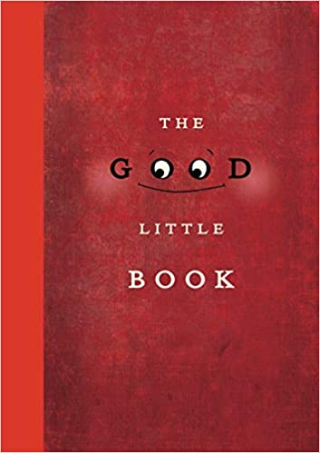
4.1: The Good Little Book by Kyo Maclear (Author), Marion Arbona (Illustrator) (2015)

“While banished to a dusty study one day “to think things over”, a boy pulls a book off a shelf and with great reluctance begins to read. As the afternoon passes, the story nabs him and carries him away. Before long, this good little book becomes his loyal companion, accompanying him everywhere ... until, one day, the book is lost. Will this bad little boy get back his good little book? Will the good little book survive on its own without a proper jacket? A quirky, enchanting tale of literary love and loss.”

Video Link: https://www.youtube.com/watch?v=eEfY1rrBXNA (4:51)

Discussion Resource: https://www.prindleinstitute.org/books/the-good-little-book/

4.2: My Many Colored Days by Dr. Seuss by (Author), Steve Johnson (Illustrator) & Lou Fancher (Illustrator) (1996)

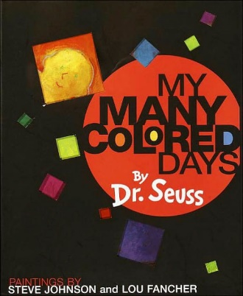
“Accompanying a manuscript Dr. Seuss wrote in 1973, was a letter outlining his hopes of finding ‘a great color artist who will not be dominated by me.’ The late Dr. Seuss saw his original text about feelings and moods as part of the ‘first book ever to be based on beautiful illustrations and sensational color.’ The quest for an artist finally ended—after the manuscript languished for more than two decades—at the paint brushes of husband-and-wife team Steve Johnson and Lou Fancher whose stunning, expressive paintings reveal such striking images as a bright red horse kicking its heels, a cool and quiet green fish, a sad and lonely purple dinosaur, and an angrily howling black wolf. Using a spectrum of vibrant colors and a menagerie of animals, this unique book does for the range of human moods and emotions what Oh, the Places You’ll Go! does for the human life cycle. Here is a wonderful way for parents to talk with children about their feelings.”

Video Link: https://www.youtube.com/watch?v=Lum83DLPXIw (3:10)

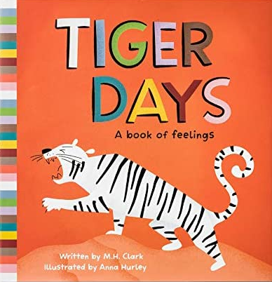
4.3: Tiger Days: A Book of Feelings by M.H. Clark (Author), Anna Hurley (Illustrator) (2019)

“From tiger fierce to snail slow, there are lots of ways to feel and be. A walk through the menagerie of Tiger Days helps young readers see all the feelings they have and the ways those feelings change.

“Through playful rhymes and colorful illustrations, this spirited book gives children new tools to understand the range of their emotions and express themselves to family, teachers, friends, and themselves.”

Video Link: https://www.youtube.com/watch?v=ANGtBkB4v6k (7:05)

4.4: In My Heart: A Book of Feelings by Jo Witek (Author) Christine Roussey (Illustrator) (2014)

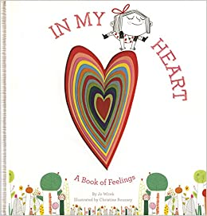
“Happiness, sadness, bravery, anger, shyness …our hearts can feel so many feelings! Some make us feel as light as a balloon, others as heavy as an elephant. In My Heart explores a full range of emotions, describing how they feel physically, inside, with language that is lyrical but also direct to empower readers to practice articulating and identifying their own emotions.”

Video Link: https://www.youtube.com/watch?v=xIfLgHBwYx4 (4:46)

4.5: How Do You Feel? by Lizzy Rockwell (2019)

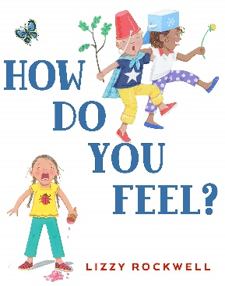
“With simple, sparse language, and bright, expressive illustrations, Lizzy Rockwell introduces very young readers to a wide range of emotions. Detailed art encourages identification and discussion of the different characters’ emotional reactions, and serves as a springboard for discussion on emotional intelligence, self-regulation, and coping skills.”

Video Link: https://www.youtube.com/watch?v=_OrcPsthaL4 (5:51)

Interview with the Author: https://www.youtube.com/watch?v=onWfdHSfcGA (4:49)

4.6: My Heart by Corinna Luyken (2019)

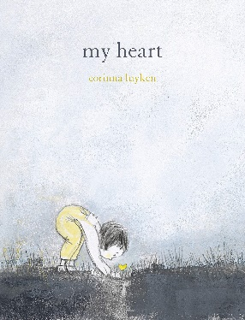
“‘My heart is a window. My heart is a slide. My heart can be closed...or opened up wide.’ Some days your heart is a puddle or a fence to keep the world out. But some days it is wide open to the love that surrounds you.”

Video Link: https://www.youtube.com/watch?v=AbMadfnFeTA (3:07)

4.7: The Color Monster by Anna Llena (Author) (2018)

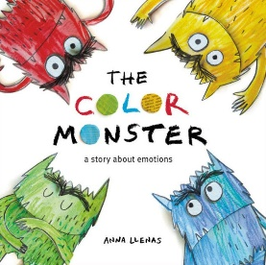
“One day, Color Monster wakes up feeling very confused. His emotions are all over the place; he feels angry, happy, calm, sad, and scared all at once! To help him, a little girl shows him what each feeling means through color. As this adorable monster learns to sort and define his mixed-up emotions, he gains self-awareness and peace as a result.”

Video Link: https://www.youtube.com/watch?v=PWujGPb6mgo (4:12)

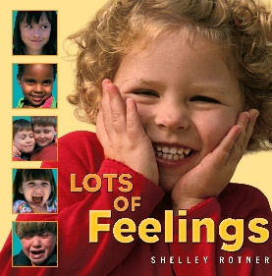
4.8: Lots of Feelings by Shelley Rotner (Author) (2003)

“Enhanced with large, bright photos of different youngsters, a concept book provides an illustrated introduction to the diverse feelings people experience, such as anger, embarrassment, and surprise.”

Video Link: https://www.youtube.com/watch?v=EyROOM2BuxQ (1:25)

4.9: Grumpy Monkey by Suzanne Lang (Author), Max Lang (Illustrator) (2018)

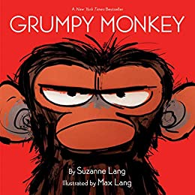
“Jim the chimpanzee is in a terrible mood for no good reason. His friends can’t understand it--how can he be in a bad mood when it’s SUCH a beautiful day? They encourage him not to hunch, to smile, and to do things that make THEM happy. But Jim can’t take all the advice...and has a BIT of a meltdown. Could it be that he just needs a day to feel grumpy?”

Video Link: https://www.youtube.com/watch?v=37RVQ2vvy9w (4:20)

4.10: The Pout Pout Fish by Deborah Diesen (Author), Dan Hanna (Illustrator) (2008)

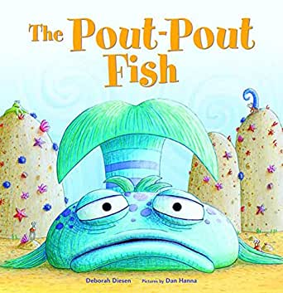
“Swim along with the pout-pout fish as he discovers that being glum and spreading “dreary wearies” isn’t really his destiny. Bright ocean colors and playful rhyme come together in Deborah Diesen’s fun fish story that’s sure to turn even the poutiest of frowns upside down.”

Video Link: https://www.youtube.com/watch?v=oqupxANpqIE (4:27)


4.11: Stand Tall, Molly Lou Melon by Patty Lovell (Author), David Catrow (Illustrator) (2001)

“Molly Lou Melon is short and clumsy, has buck teeth, and has a voice that sounds like a bullfrog being squeezed by a boa constrictor. She doesn’t mind. Her grandmother has always told her to walk proud, smile big, and sing loud, and she takes that advice to heart.

“But then Molly Lou has to start in a new school. A horrible bully picks on her on the very first day, but Molly Lou Melon knows just what to do about that.”

Video Link: https://www.youtube.com/watch?v=f0PJbx6cUFo (5:01)

4.12: Spaghetti in A Hot Dog Bun: Having the Courage to Be Who You Are by Maria Dismondy (Author), Kimberly Shaw-Peterson (Illustrator) (2008)


“Lucy is teased by a boy at school because she is different. She has the courage to be true to herself and to make the right choice when that same boy needs her help.”

Video Link: https://www.youtube.com/watch?v=3cXWrUJlOK8 (8:17)

4.13: Today I Feel Silly: And Other Moods That Make My Day by Jamie Lee Curtis by Jamie Lee Curtis (Author), Laura Cornell (Illustrator) (1998)

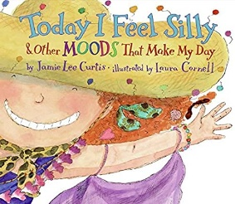
“This tale follows a little girl with curly red hair through 13 different moods. The narrative helps children learn to recognize their different moods and how to deal with each emotion.”

Video Link: https://www.youtube.com/watch?v=sMrfM4erOWw (5:51)

4.14: Visiting Feelings by Lauren J. Rubenstein JD PsyD (Author), Shelly Hehenberger (Illustrator) (2013)

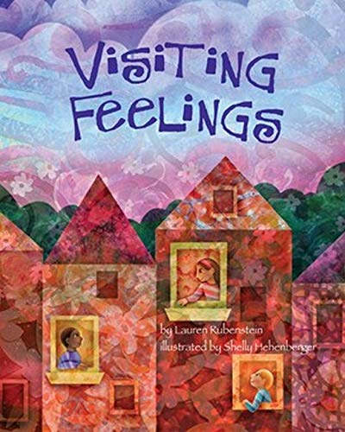
“Visiting Feelings harnesses a young child’s innate capacity to fully experience the present moment. Rather than labeling or defining specific emotions and feelings, Visiting Feelings invites children to sense, explore, and befriend any feeling with acceptance and equanimity. Children can explore their emotions with their senses and gain an understanding of how feelings can lodge in the body, as conveyed by common expressions like ‘a pit in the stomach’ or ‘lump in the throat.’

“Children can cultivate this emotional intelligence and nurture a sense of mindfulness. In essence, mindfulness is tuning into yourself and paying attention to the present moment without judging or analyzing what you are thinking or feeling. Practicing mindfulness can enhance many aspects of a person’s well-being, help develop insight and empathy, and enhance resiliency.”

Video Link: https://www.youtube.com/watch?v=E3ZuNMOt4f0 (3:06)

Anger

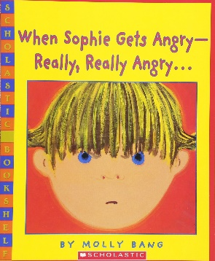
4.15: When Sophie Gets Angry—Really, Really Angry by Molly Bang (3:12)

“A little girl’s anger and emotions are illuminated by color in this story. Sophie’s temper flares when her sister demands a turn playing with a favorite stuffed gorilla. To make matters worse, Sophie’s mother seemingly takes her sister’s side. Sophie lets her anger rage in a healthy way and is able to come back to the situation calm and relaxed.”

Video Link: https://www.youtube.com/watch?v=dNfd8WFDBAY (3:12)

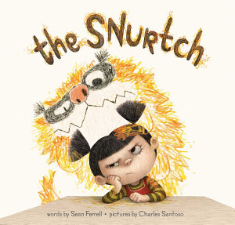
4.16: The Snurtch by Sean Ferrell (Author), Charles Santoso (Illustrator) (2016)

“Some days are Snurtch days. Ruthie is having one of those. Ruthie has a problem at school. It is not the students. It is not the classroom. It is not the reading or the writing or the math. It is something scribbly, scrunchy, grabby, burpy, and rude. It is the Snurtch. …This clever picture book takes a discerning look at the challenges of behaving and controlling your emotions—especially when your own personal monster keeps getting in the way.”

Video Link: https://www.youtube.com/watch?v=M2-4Ka_o1jo (6:36) (The second half of the video is a reading of The Color Monster)

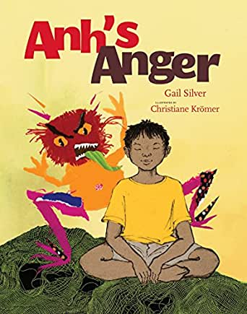
4.17: Anh’s Anger by Gail Silver (Author), Christianne Kromer (Illustrator) (2009)

“In Anh’s Anger, five-year-old Anh becomes enraged when his grandfather asks him to stop playing and come to the dinner table. The grandfather helps Anh fully experience all stages of anger by suggesting that he go to his room and, ‘sit with his anger.’ The story unfolds when Anh discovers what it means to sit with his anger. He comes to know his anger in the first person as his anger comes to life in full color and personality. Anh and his anger work through feelings together with humor and honesty to find a way to constructively release their thoughts and emotions and to reach resolve with Anh’s grandfather.”

Video Link: https://www.facebook.com/AuthorGailSilver/videos/957709638019786/ (13:40) read by the author

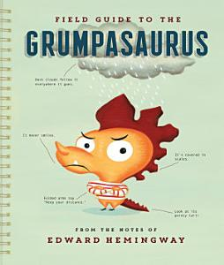
4.18: Field Guide to the Grumpasaurus by Edward Hemingway (Author) (2016)

“Have you ever met a Grumpasaurus? I bet you have. In fact, you may even have one in your own home. Want to know what makes them tick? This handy guide, meticulously researched and lovingly illustrated, tells you everything you need to know. Above all they should be handled with care—otherwise they can become VERY loud and VERY fearsome. In this appealingly modern and clever picture book, a field guide format is applied to the study of the cranky child . . . er, rather, the GRUMPASAURUS.”

Video Link: https://www.youtube.com/watch?v=UHHPe-WsmS4 (6:29)

4.19: Alexander and the Terrible Horrible No Good Very Bad Day by Judith Viorst (Author), Ray Cruz (Illustrator) 2009

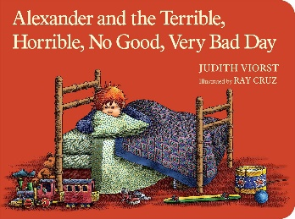
“He could tell it was going to be a terrible, horrible, no good, very bad day. He went to sleep with gum in his mouth and woke up with gum in his hair. When he got out of bed, he tripped over his skateboard and by mistake dropped his sweater in the sink while the water was running. He could tell it was going to be a terrible, horrible, no good, very bad day.

It was a terrible, horrible, no good, very bad day. Nothing at all was right. Everything went wrong, right down to lima beans for supper and kissing on TV. What do you do on a day like that? Well, you may think about going to Australia. You may also be glad to find that some days are like that for other people too.”

Video Link: https://www.youtube.com/watch?v=w6HhKlpp7ok (6:29)

Fear

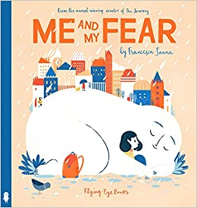
4.20: Me and My Fear by Francesca Sanna (Author) (2018)

“When a young immigrant girl has to travel to a new country and start at a new school, she is accompanied by her Fear who tells her to be alone and afraid, growing bigger and bigger every day with questions like ‘how can you hope to make new friends if you don’t understand their language?’ But this little girl is stronger than her Fear. …This book shows us the importance of sharing your Fear with others--after all, everyone carries a Fear with them, even if it’s small enough to fit into their pocket!”

Video Link: https://www.youtube.com/watch?v=yXcCZvxpym8 (3:46)

4.21: Take a Deep Breath by Sue Graves (Author), Desideria Guicciardini (Illustrator) (2013)

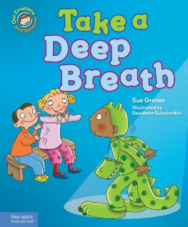
“Lucy is afraid of dogs, Josh doesn’t like to go in the pool, Dan doesn’t want the nurse to touch his bruised knee, and Ben is afraid to go on stage something scares them, they can take a deep breath and feel brave enough to get through their ordeals.”

Video Link: https://www.youtube.com/watch?v=jRAbh39j4ZA (5:03)

4.22: After the Fall (How Humpty Dumpty Got Back Up Again) by Dan Santat (Author, Illustrator) (2017)

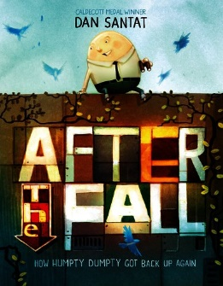
“Everyone knows that when Humpty Dumpty sat on a wall, Humpty Dumpty had a great fall. But what happened after? …[This] poignant tale follows Humpty Dumpty, an avid bird watcher whose favorite place to be is high up on the city wall―that is, until after his famous fall. Now terrified of heights, Humpty can longer do many of the things he loves most. Will he summon the courage to face his fear?”

Video Link: https://www.youtube.com/watch?v=uIH91_PCmqM (5:14)

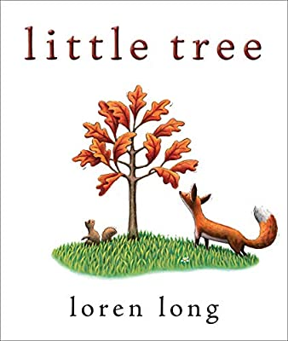
4.23: Little Tree by Loren Long (Author, Illustrator) (2015)

“‘In the middle of a little forest, there lives a Little Tree who loves his life and the splendid leaves that keep him cool in the heat of long summer days. Life is perfect just the way it is.’

“Autumn arrives, and with it the cool winds that ruffle Little Tree’s leaves. One by one the other trees drop their leaves, facing the cold of winter head on. But not Little Tree—he hugs his leaves as tightly as he can. Year after year Little Tree remains unchanged, despite words of encouragement from a squirrel, a fawn, and a fox, his leaves having long since turned brown and withered. As Little Tree sits in the shadow of the other trees, now grown sturdy and tall as though to touch the sun, he remembers when they were all the same size. And he knows he has an important decision to make.”

Video Link: https://www.youtube.com/watch?v=wopgngVW1xs (4:29)

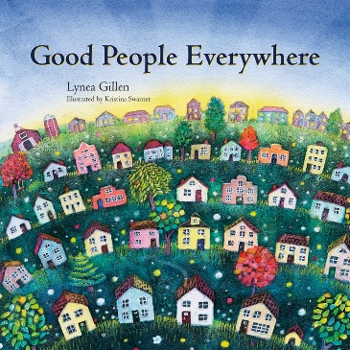
4.24: Good People Everywhere by Lynea Gillen (Author), Kristina Swarner (Illustrator) (2012)

“A colorful picture book that will warm the hearts of children and adults alike, each of its pages contain endearing examples and vibrant illustrations to inspire children to grow into grateful, caring, and giving people. It provides a wonderful way to calm children before sleep, ease their fears, and help them develop an appreciation for good work. Also included are activity pages to help children practice skills for creating gratitude, compassion, and beauty in daily life.”

Video Link: https://www.youtube.com/watch?v=zkSTgWnPTkE (2:36)

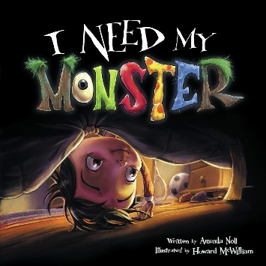
4.25: I Need my Monster by Amanda Noll (Author), Howard McWilliam (Illustrator) (2009)

“A unique monster-under-the-bed story with the perfect balance of giggles and shivers, this picture book relies on the power of humor over fear, appeals to a child’s love for creatures both alarming and absurd, and glorifies the scope of a child’s imagination. One night, when Ethan checks under his bed for his monster, Gabe, he finds a note from him instead: “Gone fishing. Back in a week.” Ethan knows that without Gabe’s familiar nightly scares he doesn’t stand a chance of getting to sleep, so Ethan interviews potential substitutes to see if they’ve got the right equipment for the job—pointy teeth, sharp claws, and a long tail—but none of them proves scary enough for Ethan. When Gabe returns sooner than expected from his fishing trip, Ethan is thrilled. It turns out that Gabe didn’t enjoy fishing because the fish scared too easily.”

Video Link: https://www.youtube.com/watch?v=uEQIvwtAdNM (11:04)

Sadness (and Grief)

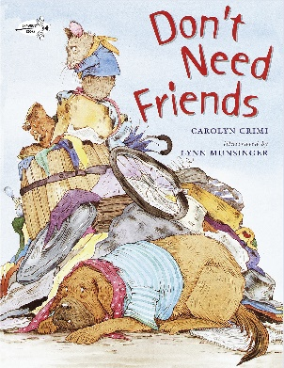
4.26: Don’t Need Friends by Carolyn Crimi (Author), Lynn Munsinger (Illustrator) (2001)

“Rat’s best friend moves out of the Junkyard. Devastated, Rat masks his sadness with an attitude that he doesn’t need friends. He rejects all help and friendships from neighbors. Dog moves into the Junkyard with the same, if not worse, attitude. Rat and Dog have met their match in each other.

“Then disaster strikes with cold weather and food. It forces Dog and Rat to acknowledge that they care for each other and how they need one another.

“So often when hurting, people hide behind a mask of grumpiness or artificial friendliness. Meanwhile, they are hurting inside. Don’t Need Friends teach children empathy and to look beyond the obvious. The story shows the benefits of lasting relationships like friendship, and the pain when losing a friend.”

Video Link: https://www.youtube.com/watch?v=k-xTUAoeuLc (8:07)

4.27: When Sadness is at Your Door by Eva Eland (Author) (2019)

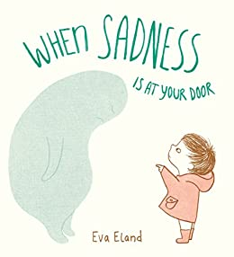
“Sadness can be scary and confusing at any age! When we feel sad, especially for long periods of time, it can seem as if the sadness is a part of who we are--an overwhelming, invisible, and scary sensation.

“In When Sadness Is at Your Door, Eva Eland brilliantly approaches this feeling as if it is a visitor. She gives it a shape and a face, and encourages the reader to give it a name, all of which helps to demystify it and distinguish it from ourselves. She suggests activities to do with it, like sitting quietly, drawing, and going outside for a walk. The beauty of this approach is in the respect the book has for the feeling, and the absence of a narrative that encourages the reader to ‘get over’ it or indicates that it’s ‘bad,’ both of which are anxiety-producing notions.”

Video Link: https://www.youtube.com/watch?v=yPSWY7C73fo (2:01)

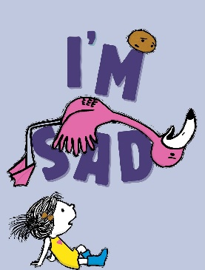
4.28: I’m Sad by Michael Ian Black (Author), Debbie Ridpath Ohi (Illustrator) (2018)

“A girl, a potato, and a very sad flamingo star in this charming sequel to I’m Bored…. Everyone feels sad sometimes—even flamingos.

Sigh. When Flamingo announces he’s feeling down, the little girl and Potato try to cheer him up, but nothing seems to work. Not even dirt! (Which usually works for Potato.) Flamingo learns that he will not always feel this way. And his friends learn that sometimes being a friend means you don’t have to cheer someone up. You just have to stick by your pal no matter how they feel. Even if they’re a potato.”

Video Link: https://www.youtube.com/watch?v=NwSLEkE0DmA (3:59)

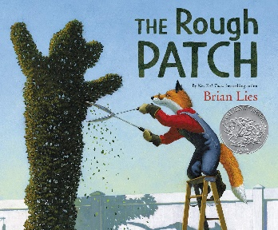
4.29: The Rough Patch by Brian Lies (Author, Illustrator) (2018)

“Evan and his dog do everything together, from eating ice cream to caring for their prize-winning garden, which grows big and beautiful. One day the unthinkable happens: Evan’s dog dies. Heartbroken, Evan destroys the garden and everything in it. The ground becomes overgrown with prickly weeds and thorns, and Evan embraces the chaos.

“But beauty grows in the darkest of places, and when a twisting vine turns into an immense pumpkin, Evan is drawn out of his isolation and back to the county fair, where friendships—old and new—await.”
Video Link: https://www.youtube.com/watch?v=ezsUPXkC-R4 (3:44)

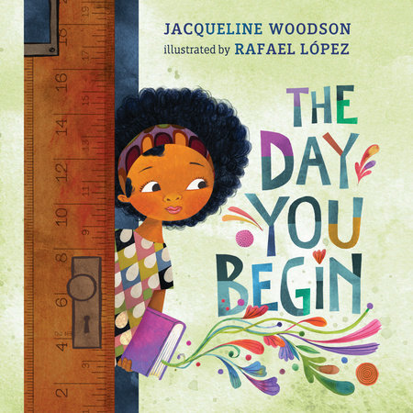
4.30: The Day You Begin by Jacqueline Woodson (Author), Rafael López (Illustrator) (2018)

… “A poignant, yet heartening book about finding courage to connect, even when you feel scared and alone. ‘There will be times when you walk into a room’ and no one there is quite like you.

“There are many reasons to feel different. Maybe it’s how you look or talk, or where you’re from; maybe it’s what you eat, or something just as random. It’s not easy to take those first steps into a place where nobody really knows you yet, but somehow you do it.

… “We all feel like outsiders sometimes-and how brave it is that we go forth anyway. And that sometimes, when we reach out and begin to share our stories, others will be happy to meet us halfway.”

Video Link: https://www.youtube.com/watch?v=DNrc_-TNFYU (7:26)

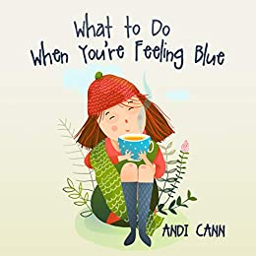
4.31: What to Do When You’re Feeling Blue by Andi Cann (Author) (2019)
“Sadness happens. Let’s help kids cope with it. Children aren’t always prepared for the emotions that overcome them. Adults aren’t either.
“Kappy is a regular little kid who feels a variety of emotions all day long. Sometimes she feels happy and glad, sometimes she feels blue and sad. Talking with her Dad about her feelings helps her understand her feelings and gives her ideas for things she can try when some days are blue.
“Parents appreciate the opportunity to talk with their children about happiness and sadness. It honors emotions while problem-solving how to perk up when feeling sad.”

Video Link: https://www.youtube.com/watch?v=v_Ehfo6wtPQ (6:15)

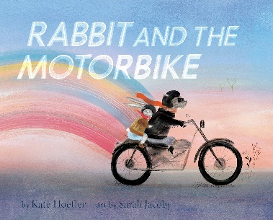
4.32: Rabbit and the Motorbike by Kate Hoefler (Author), Sarah Jacoby (Illustrator) (2019)
“A timeless fable of the journey from grief to acceptance that will touch every reader: Rabbit isn’t sure he’ll ever be brave enough to go on an adventure. He’s a homebody who lives in a quiet field of wheat he dreams of leaving every night. His world is enlarged by his friend Dog and Dog’s tales of motorbike adventures. But one day, Dog is gone, and with him, go the stories Rabbit loves so much. Dare Rabbit pick up the motorbike and live his own story?”

Video Link: https://www.facebook.com/JenniferGarner/videos/rabbit-and-the-motorbike-by-kate-hoefler-illustrated-by-sarah-jacoby-published-b/668636837262226/ (9:15)

4.33: Maybe Tomorrow? by Charlotte Agell (Author), Ana Ramírez González (Illustrator) (2019)
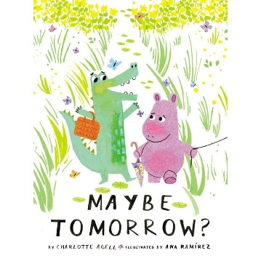
“Elba has a big block. She’s been dragging it around for a long time. Norris dances everywhere he goes, even uphill. He is always surrounded by a happy cloud of butterflies. Can Norris and his butterflies help ease Elba’s sadness and convince her to join them on a trip to the ocean?
“This tender exploration of loss illuminates the sustaining power of kindness, empathy, and friendship. It will resonate with anyone who has experienced hardship or grief, from the death of a loved one or a pet, to the transition to a new home, family situation, or learning environment. It is especially comforting during this time of social distancing and the uncertainty around what the future holds, sensitively demonstrating that together we can make it through anything if we take care of one another.”

Video Link: https://www.youtube.com/watch?v=jQJ-Gfen94Y (15:01) (Reading from 3:20 to 12:30)

4.34: Virginia Wolf by Kyo Maclear (Author), Isabelle Arsenault (Illustrator) (2012)

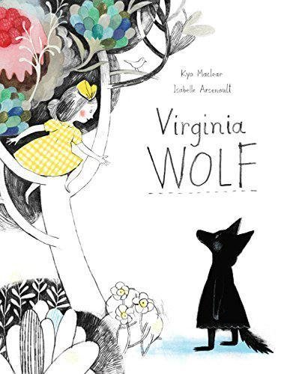
“Vanessa’s sister, Virginia, is in a ‘wolfish mood’—growling, howling and acting very strange. It’s a funk so fierce, the whole household feels topsy-turvy. Vanessa tries everything she can think of to cheer her up, but nothing seems to work. Then Virginia tells Vanessa about an imaginary, perfect place called Bloomsberry. Armed with an idea, Vanessa begins to paint Bloomsberry on the bedroom walls, transforming them into a beautiful garden complete with a ladder and swing so that ‘what was down could climb up.’ Before long, Virginia, too, has picked up a brush and undergoes a surprising transformation of her own. Loosely based on the relationship between author Virginia Woolf and her sister, painter Vanessa Bell, Virginia Wolf is an uplifting story for readers of all ages.”

Video Link: https://www.youtube.com/watch?v=ahBvfG4sk0A (7:22)

4.35: The Boy Who Didn’t Want to Be Sad by Dr. Robert Goldblatt PsyD (Author, Illustrator) (2004)

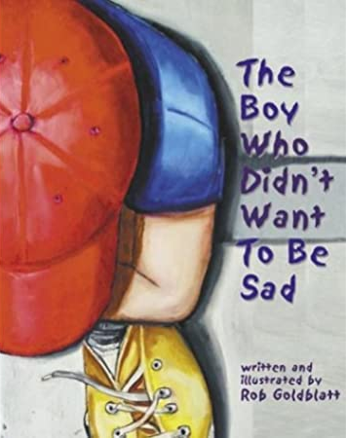
“‘There once was a boy who didn't want to be sad. So, he made a decision. He made a plan.’

“The plan was to get rid of everything that made him sad. but what he found out when he tried to get rid of sadness was a very, very big lesson in happiness. This book helps children face and even celebrate their emotions, even the uncomfortable ones, as parts of the whole experience of being alive.”

Video Link: https://www.youtube.com/watch?v=mOD0w9vCT-4 (14:06) (Story runs from 3:21 to 10:40)

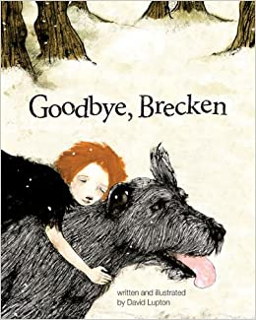
4.36: Goodbye, Brecken by David Lupton (Author, Illustrator) (2013)

Goodbye, Brecken is an evocative and somber telling of a girl's loss surrounding the death of her dog. With this loss comes her first experience with grief and profound sadness. As she comes to accept Brecken's death, she can deal with her grief and remember her lost dog with happiness.

Happiness

4.37: Across the Blue Mountains by Emma Chichester Clark (1993)

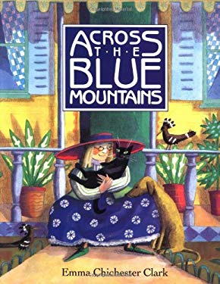
“Miss Bilberry just can’t help wondering whether she might be happier if she lived on the other side of the mountains. So, with her cat, Chester, her dog, Cecilie, and her two birds, Chitty and Chatty, at her side, and all her worldly possessions in a wheelbarrow, she sets off to find out.”

4.38: My Heart Fills With Happiness by Monique Gray Smith (Author), Julie Flett (Illustrator) (2016)

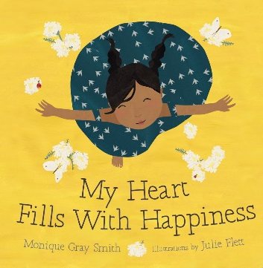
“The sun on your face. The smell of warm bannock baking in the oven. Holding the hand of someone you love. What fills your heart with happiness? This beautiful board book, with illustrations from celebrated artist Julie Flett, serves as a reminder for little ones and adults alike to reflect on and cherish the moments in life that bring us joy.

“…Monique Gray Smith wrote My Heart Fills with Happiness to support the wellness of Indigenous children and families, and to encourage young children to reflect on what makes them happy.”

Video Clip: https://www.youtube.com/watch?v=tO77a3-6lbo (2:38)

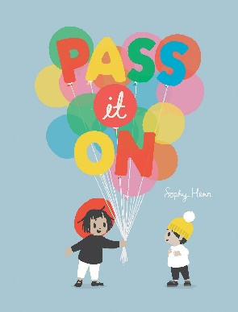
4.39: Pass it On by Sophy Henn (Author, Illustrator) (2017)

“‘When you see something terrific, smile a smile and pass it on! If you chance upon a chuckle, hee hee hee and pass it on. Should you spot a thing of wonder, jump for joy and pass it on!’

So begins Sophy Henn’s ode to the excitement of sharing happiness with others. With a refrain that begs to be uttered before every turn of the page, children will eagerly read alongside their parents as they discover how wonderful—and fun—it is to share the good things in life. After all, if you spread happiness to others, even on a gray, rainy day, when you least expect it, like a bolt out of the blue, a smile or a chuckle might be passed right back to you.”

Video Link: https://www.youtube.com/watch?v=HG_HsTBa_-Q (1:58)

4.40: Augustus and His Smile by Catherine Rayner (Author) (2007)

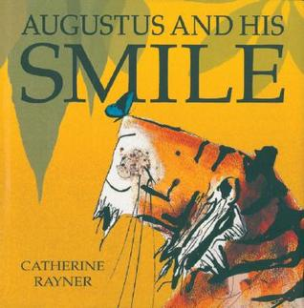
“Augustus the tiger was sad. He had lost his smile. So, he did a HUGE tigery stretch, and set off to find it. Stunning illustrations celebrate the beauty of the world and the simple happiness it brings to us. An imaginative book for children who love to explore the world around them.”

Video Link: https://www.youtube.com/watch?v=qFDFB36fWwk (3:01)

4.41: Other Books About Emotions

Reviewed by Happily Ever Elephants these are about Loneliness, Worry, Jealously, Insecurity, Love, and Curiosity at https://happilyeverelephants.com/home/children-books-about-feelings/list

5.0: Music, Videos, and Related Resources for Children

5.1: Inside Out Videos (from the 2015 Pixar movie Inside Out)

5:1.1: Inside Out: Guessing the feelings (3:16)

Short clips introducing each of Riley’s emotions: Joy, Sadness, Anger, Disgust, and Fear

Link to Video Link: https://www.youtube.com/watch?v=dOkyKyVFnSs

5:1.2: 20 short clips from the movie Inside Out

Link: https://www.thehelpfulcounselor.com/20-inside-out-clips-to-help-teach-children-about-feelings/

5:1.3: What causes anxiety and depression from Inside Out by Mind Set (5:58)

This video talks about depression and anxiety.

Video Link: https://www.youtube.com/watch?v=tNsTy-j_sQs

5:1.4: Inside Out official clip compilation (2015) (8:23)

Video Link: https://www.youtube.com/watch?v=3wk8UyVFE74

5:1.5: Inside Out Clips (2015) Disney Pixar (13:15)

Video Link: https://www.youtube.com/watch?v=Uky-jgd3M3E

5:1.6: Inside Out Clips - Best Riley Scenes (2015) Disney Pixar (9:12)

Video Link: https://www.youtube.com/watch?v=AN34R_Enj-g

5:1.7: Inside Out Movie (1 hour 34 minutes)

Riley is a happy, hockey-loving 11-year-old Midwestern girl, but her world turns upside-down when she and her parents move to San Francisco. Riley’s emotions—led by Joy—try to guide her through this difficult, life-changing event. However, the stress of the move brings Sadness to the forefront. When Joy and Sadness are inadvertently swept into the far reaches of Riley’s mind, the only emotions left in Headquarters are Anger, Fear and Disgust.

Link: https://www.amazon.com/Inside-Out-Theatrical-Amy-Poehler/dp/B015D4GX80 (to rent or buy)

5.2: Articles

5.2.1: Synopsis of the movie Inside Out

Link: https://www.imdb.com/title/tt2096673/plotsummary

5.2.2: Bringing Your Emotions to Life: Ways to work with five key emotions in Inside Out by Frederic and Mary Ann Brussat

Link: https://www.spiritualityandpractice.com/practices/features/view/27966/bringing-your-emotions-to-life

5.2.3: Inner Voices: Learning about Human Qualities (i.e., emotions) through Writing by J. Ruth Gendler

Link: http://mseffie.com/assignments/book_of_qualities/Interview.pdf

5.2.4: Four Lessons from “Inside Out” to Discuss with Kids by Jason March and Vicki Zakrewski

This Pixar film moved viewers young and old to take a look inside their own minds. In this excellent article from the Greater Good Magazine, the lessons to explore are 1. Happiness is not just about joy; 2. Don’t try to force happiness; Sadness is vital to our well-being; and 4. Mindfully embrace—rather than suppress—tough emotions.

Link: https://greatergood.berkeley.edu/article/item/four_lessons_from_inside_out_to_discuss_with_kids

5.2.5: 8 Things “Inside Out” Teaches Viewers About Emotions, Memory and the Mind by Ashley Lee

Good Article.

Link: https://www.hollywoodreporter.com/news/8-things-inside-teaches-viewers-804052

5.3: Fourteen Discussion Resources for the movie Inside Out

Parent Viewing Guide for the Pixar Movie Inside Out Link: http://mentalhealthinnovation.org/wp-content/uploads/2020/05/NMHIC_MovieViewingGuide-PixarInsideOut_FINAL_052020.pdf (Excellent, questions are time-indexed to the movie)

Inside Out and Emotional Intelligence link: https://www.oaktreecounselor.com/blog/inside-out-emotional-intelligence (With lots of links to other good materials)

Inside Out Study Guide Flash Cards (40) link: https://quizlet.com/212648732/inside-out-study-guide-flash-cards/ (Click on card question and it will flip to how the answer / Free but you need to sign-up to see all the flash cards)

Discussion Questions Link: http://www.unseenfootprints.com/inside-out-discussion-questions/

Guide for Teens link: https://www.burdtherapy.com/wp-content/uploads/2015/07/Inside-Out-Study-Guide-Understanding-Emotions1.pdf

K-8 Activities link: https://www.burdtherapy.com/4-ways-help-kids-understand-emotions-with-inside-out-disneypixar/

Discussion Points/Questions link: https://themodernparent.net/using-movie-inside-out-to-discuss-emotions-with-kids/

Comments & Questions: https://phdsandpigtails.com/2015/06/24/inside-out-the-adventure-of-life-and-complex-emotions-with-discussion-questions/

Five Things to Discuss about Inside Out link: https://justmind.org/5-things-to-discuss-with-kids-from-inside-out/

Inside Out & Therapy link: https://ct.counseling.org/2016/03/using-inside-out-to-discuss-emotions-with-children-in-therapy/

Five Key Questions about Inside Out link: https://www.bonbonbreak.com/conversations-after-inside-out/

Game Board and Questions link: https://www.awortheyread.com/using-disneys-inside-out-movie-to-talk-about-emotions-printable/

Parent’s Viewing Guide & Questions link: https://www.cfchildren.org/blog/2015/06/inside-out-a-parents-guide-to-viewing-teaching-sel-skills/

Inside Out Study Guide link: https://www.aisnsw.edu.au/Course%20and%20Conference%20Materials/Inside%20Out%20studyguide.pdf

5.4: Other Videos

5.4.1: Guess and Learn EMOTIONS and FEELINGS for Kids / Teach Emotions to Kids by Kreative Leadership (5:53)

Video Link: https://www.youtube.com/watch?v=MeNY-RxDJig

6.0: Curriculum & Theme-Based Classroom Activities for Children

6.1: Emotional Intelligence Activity Packets for Ages 5-18

Each activity packet features 30 activities in the following five areas; good for use in the classroom and at home.

InTRApersonal: Self-Regard, Emotional Self-Awareness, Assertiveness, Independence & Self-Actualization

InTERpersonal: Empathy, Social Responsibility & Interpersonal Relationship

Adaptability: Reality Testing, Flexibility & Problem Solving

Stress Management: Stress Tolerance & Impulse Control

General Mood: Optimism &Happiness

6.1.1: Emotional Intelligence Activities for Children Ages 5-7

Link: https://www.ong.ohio.gov/frg/FRGresources/emotional_activities_5-7.pdf

6.1.2: Emotional Intelligence Activities for Children Ages 8-10

Link: https://www.ong.ohio.gov/frg/frgresources/emotional_intellegence_8-10.pdf

6.1.3: Emotional Intelligence Activities for Pre-teens Ages 11-12

Link: https://ong.ohio.gov/frg/FRGresources/emotional_intellegence_11-12.pdf

6.1.4: Emotional Intelligence Activities Teens Ages 13-18

Link: https://ong.ohio.gov/frg/FRGresources/emotional_intellegence_13-18.pdf

6.2: Focusing and Calming Activities for Children by Deborah Plummer

It is never too soon for children to learn the process of peaceful conflict resolution. This book teaches children how to calm themselves, state the problem, listen, think of solutions, try one, evaluate results, and even agree to disagree when a solution isn’t possible. Included are skill-building games and role plays for adults to use with children.

Link: https://www.apperson.com/teach-talk/10-activities-to-help-students-explore-emotions

Resources for Youth & Adults
7.0: Reflections, Readings, Stories & Poetry
7.1: Developing Emotional Intelligence by Katie Klear (264 words)
…According to [Harrison] Monarth, “Emotional intelligence is the ability to both recognize your own emotions [and] understand your own emotions, and the impact they have on your thinking, on your behavior, as well as how your emotions impact the thinking and behaviors of others, the feelings of others.” Taking that first component of the definition a step further, he elaborated: “Emotional intelligence is being able to not just understand all of this but also to manage it …for more productive outcomes.”
…Alicia Del Real…has curated six pillars for what EI looks like…. “First is a minimum of defensiveness and arrogance,” she said. “Two is accurate empathy, being able to put yourself in someone else’s shoes and giving them what they need. Third is living your social values; define what you stand for and walk your talk. Four is appropriate transparency, having open and honest communication even when it makes you feel vulnerable. Five is emotional courage. Finally, the sixth condition is a tolerance of paradox [of] ambiguity.”
…Bill Benjamin …describes the emotional and cognitive parts of the brain as two strains of an intertwined rope.
…Del Real stated, “It’s hard for us to develop and reach our potential when we aren’t in touch with our blindspots, so it all starts with emotional intelligence.”
…Whereas the IQ component of the brain is relatively fixed, EI can be improved.
… “The only way to build emotional intelligence is through practice,” Del Real said. “You really have to practice it, set a goal, share it socially and then practice it, the only way to move the needle.”
Source: https://www.chieflearningofficer.com/2020/03/03/emotional-intelligence-is-a-critical-skill-for-development/

7.2: Improving Emotional Intelligence by Nikita Duggal (257 words)
To a large degree, our emotional intelligence starts in childhood with how we’re raised, but as adults, we can take steps to get emotionally “smarter.” Justin Bariso, author of EQ, Applied: A Real-World Approach to Emotional Intelligence, offers seven ways to improve emotional intelligence….
- Reflect on your emotions. This is where self-awareness begins. To grow in emotional intelligence, think about your own emotions and how you typically react to negative situations, whether they involve a co-worker, family member or stranger. When you’re more aware of your emotions and typical reactions, you can start to control them.
- Ask for perspective. What we perceive to be reality is often quite different from what those around us are seeing. Start getting input from others to understand how you come across in emotionally charged situations.
- Observe. Once you’ve increased your self-awareness and you understand how you’re coming across, pay more attention to your emotions.
- Pause for a moment. Stop and think before you act or speak. It’s hard to do, but keep working at it and it will become a habit.
- Become more empathetic by understanding the “why.” Try to understand the “why” behind another person’s feelings or emotions.
- Choose to learn from criticism. Who likes criticism? Possibly no one. But it’s inevitable. When we choose to learn from criticism rather than simply defend our behaviors, we can grow in emotional intelligence.
- Practice, practice, practice. Becoming more emotionally intelligent won’t happen overnight, but it can happen—with effort, patience, and a lot of practice.
Source: https://www.simplilearn.com/emotional-intelligence-what-why-and-how-article

7.3: A New Political Gestalt by Marianne Williamson (255 words)
The Greek root of the word politics does not mean “of the government” but “of the citizen.” We need a new political gestalt in America …to more accurately reflect not only what we do, but who we are and are becoming. Politics should include more than just changes in government; it should include changes in us. We are what America is. There are internal as well as external aspects to a nation, and to the process of societal change. From hatred, racism, and cynicism to hope, creativity, and forgiveness, both the inner and the outer America are now political issues.
Martin Luther King, Jr., spoke often of our need to have “tough minds and tender hearts.” He himself displayed that combination brilliantly. Many tough thinkers in America today lack heart, while too many tender hearts lack mental and intellectual acumen. Fuzzy thinking is just one step above not thinking. We must pool our intellectual and emotional strengths to create an elixir of healing for our national distress. [This is emotional intelligence.]
We have the yang; we must reclaim the yin. We have the intelligence; we must retrieve our souls. We will find a way to put the two together. And out of that union will flow such power…. There is a wellspring of love and wisdom in each of us, which is …a powerful political force. Our …true enemy is …fear-laden thoughts that cling …and sap us of our strength. We must make a stand for our better selves. We must recommit to essential truths, both spiritual and political.
Source: https://www.spiritualityandpractice.com/book-reviews/excerpts/view/13289

7.4: Dispelling Myths About Emotional Intelligence by Marina Fiori (240 words)
…Three false myths about emotionality and (in)effectiveness are:
- Emotions do not necessarily bias perception and reasoning. Emotions in themselves are not right or wrong, good or bad, correct or incorrect. Emotions are simply pieces of information telling us how we are currently navigating our world. Depending on how we understand and use this piece of information we may end up being either supported or impaired by emotions.
- Being emotional does not equal being weak. Feeling deep emotions, having a higher level of emotional self-awareness, being more accurate in labeling and attributing emotions to others, as well as being more capable to regulate emotions are all characteristics that may foster creativity and overall performance, sustaining the development of one's full potential. People who disclose their feelings are more authentic and are perceived to be so by others. …Speaking one's mind through emotions is a demonstration of power, not a weakness.
- Being emotionally intelligent is different from being overwhelmed by emotions. The emotionally intelligent person is someone capable of managing the ups and downs that positive and negative emotions may bring; someone who has a more accurate perception of one's own emotions and those of others and uses this information to better adjust to the social environment; someone who has a profound understanding of emotions and shows it through empathic concern; someone who can prevent negative emotions from impeding thinking and who can channel them as a motivational force.
Source: https://www.hospitalitynet.org/opinion/4099494.html

7.5: Seek Emotional Freedom by Judith Orloff (205 words)
Our society is in the midst of an emotional meltdown. People are restless, volatile, our tempers about to blow. Prozac [is over] prescribed, …[opioid addiction is rampant, and suicide rates are increasing] Domestic violence occurs in one out of six households. Fifty percent of drivers who're cut off respond with horn honking, yelling, obscene gestures, or even road rage. Half of our marriages end in divorce.
None of this is how we want life to be. Our pressure cooker society pushes us to our emotional limits. We deserve relief from getting crucified by daily stresses. We deserve to be happier, to be more comfortable in our own skins, to have nurturing relationships. . . . It’s lunacy to put up with being chronically anxious, fatigued, or depressed as so many of us have. I rebel against that cheerless status quo, and hope you will too. . . .
Though we commonly think of freedom as uncensored speech, emancipation from slavery, and the right to vote and worship as we choose, you can't achieve total freedom until you learn to take charge of emotions, instead of them running you. This is a radical paradigm shift we all can make, regardless of our present anxieties or past hardships.
Source: https://www.spiritualityandpractice.com/quotes/quotations/view/42508/spiritual-quotation

7.6: Unlikely Teachers by Anthony de Mello (124 words)
Every painful event contains in itself a seed of growth and liberation. In the light of this truth, return to your life now and take a look at one or another of the events that you are not grateful for, and see if you can discover the potential for growth that they contain which you were unaware of and therefore failed to benefit from. Now think of some recent event that caused you pain, that produced negative feelings in you. Whoever or whatever caused those feelings was your teacher, because they revealed so much to you about yourself that you probably did not know. And they offered you an invitation and a challenge to self-understanding, self-discovery, and therefore to growth and life and freedom.
Source: https://www.spiritualityandpractice.com/quotes/quotations/view/42519/spiritual-quotation

7.7: Understanding the Five Categories of Emotional Intelligence (EQ) by Michael Akers & Grover Porter (315 words)
1. Self-awareness. The ability to recognize an emotion as it “happens” is the key to your EQ. Developing self-awareness requires tuning in to your true feelings. The major elements …are:
- Emotional awareness. Your ability to recognize your own emotions and their effects.
- Self-confidence. Sureness about your self-worth and capabilities.
2. Self-regulation. You often have little control over when you experience emotions. You can, however, …alleviate negative emotions such as anger, anxiety or depression. …Self-regulation involves:
- Self-control. Managing disruptive impulses.
- Trustworthiness. Maintaining standards of honesty and integrity.
- Conscientiousness. Taking responsibility for your own performance.
- Adaptability. Handling change with flexibility.
- Innovation. Being open to new ideas.
3. Motivation. To motivate yourself for any achievement requires clear goals and a positive attitude. …Motivation is made up of:
- Achievement drive. Your constant striving …to meet a standard of excellence.
- Commitment. Aligning with the goals of the group or organization.
- Initiative. Readying yourself to act on opportunities.
- Optimism. Pursuing goals persistently despite obstacles and setbacks.
4. Empathy. …An empathetic person excels at:
- Service orientation. Anticipating, recognizing and meeting …others’ needs.
- Developing others. Sensing what others need to progress and bolstering their abilities.
- Leveraging diversity. Cultivating opportunities through diverse people.
- Political awareness. Reading a group’s emotional currents and power relationships.
- Understanding others. Discerning the feelings behind the needs and wants of others.
5. Social skills. The development of good interpersonal skills is tantamount to success in …life and career. …Among the most useful skills are:
- Influence. Wielding effective persuasion tactics.
- Communication. Sending clear messages.
- Leadership. Inspiring and guiding groups and people.
- Change catalyst. Initiating or managing change.
- Conflict management. Understanding, negotiating, and resolving disagreements.
- Building bonds. Nurturing instrumental relationships.
- Collaboration and cooperation. Working with others toward shared goals.
- Team capabilities. Creating group synergy in pursuing collective goals.
Source: https://psychcentral.com/lib/what-is-emotional-intelligence-eq/

7.8: Blinded by Certainty by Susan Jeffers (159 words)
We need only look around to see that the blind certainty that so many of us possess is responsible for creating tension and unrest in our lives instead of flow. In a world of discovery, instead of blind certainty, we can relax and let go of our need for things to be a certain way. This does not mean we stop taking action to create important changes in our lives and in our world, but it does mean that we let go of how we think it's supposed to be or how it should turn out. Again, we let go because we don't really know the Grand Design. When we drop our attachment to any outcome, we start feeling that all-important WONDER. We start feeling curious about how it will turn out. The emotional hold that attachment creates melts away, and we are free to engage with others in a more encompassing way. Life gets bigger and certainly easier.
Source: https://www.spiritualityandpractice.com/quotes/quotations/view/42527/spiritual-quotation

7.9: An Ice Age of the Heart by Piero Ferrucci (208 words)
Human feelings do not always remain the same. They change in emphasis and tone through the centuries. Thus, we can talk about a history of emotions. I am convinced that we are going through an Ice Age of the heart, which began more or less with the Industrial Revolution and continues in our post-industrial age. The causes of this Ice Age are many: new living conditions and forms of work, the establishing of new technologies, the decline of the extended family, the great migrations in which people are uprooted from their birthplace, the weakening of values, the fragmentation and superficiality of the contemporary world, the accelerating pace of life.
Do not misunderstand me—I am not pining for the good old days. On the contrary, I think we are living in an extraordinary epoch. If we wish to cultivate solidarity, kindness, care for others, we have more knowledge, instruments, and possibilities than ever before. Still, the Ice Age we are passing through is worrisome, and I am not surprised that it goes hand in hand with the epidemic of depression and panic attacks, probably the two psychological disturbances most linked to lack of warmth and of a reassuring and protective community, and to a weakened sense of belonging.
Source: https://www.spiritualityandpractice.com/quotes/quotations/view/33790/spiritual-quotation

7.10: Wabi Sabi Emotions by Arielle Ford (268 words)
I remember being spellbound when I first came across the concept of Wabi Sabi. It was late afternoon on a cold November day more than twenty years ago. I was gazing out my office window, enjoying the western sky as it turned shades of crimson with splashes of orange light around the setting sun. I picked up a magazine and came across an article with a striking black-and-white photograph of a large Asian urn sitting on a pedestal, with a long, crooked crack down the middle. The crack was highlighted by gallery lighting. Huh? It did not compute. The headline read, "The Art of Wabi Sabi."
Curious, I began reading about this exotic-sounding phrase. In the world of Wabi Sabi, the urn in the photograph was even more beautiful and valued because of the crack, because of its imperfection. Singer and poet Leonard Cohen clearly expressed this basic Wabi Sabi principle in his haunting song Anthem: "Ring the bells that still can ring; forget your perfect offering. There is a crack in everything; that's how the light gets in."
Seeing the ways that Wabi Sabi helps to illuminate the hidden beauty in life had an immediate and profound impact on me, and it wasn't long before I began to realize how this ancient art form relates to love. So many things began to make sense. I mean, I already knew I wasn't perfect and wasn't capable of perfection, but I had never entertained the idea that not only should I not strive for perfection, but that my imperfection is in its own way more valuable than perfection itself. [It follows that emotions are not perfect; they are what they are.]
Source: https://www.spiritualityandpractice.com/quotes/quotations/view/42528/spiritual-quotation

7.11: Engaging Your Negative Emotion by Kristin Ritzau (176 words)
Engaging online with images and stories about important democratic matters can kindle strong emotions. Sometimes the emotions are joyful; other times fear and anxiety are triggered. The adrenaline rushes of these responses can be overwhelming.
This practice invites you to welcome the anger, fear, and anxiety. In the first step, take a deep breath and acknowledge the emotion that you feel instead of trying to ignore it or let it consume you. Next, close your eyes and give the emotion a personality and/or a shape. Perhaps it takes on the persona of an animal or character. Ask it why it is there and what it needs or longs for. Chances are, it is trying to protect you from something or help you figure out your passion for what you think the world needs. Finally, reflect upon what this emotional part needs to allow it to relax.
Often your wisdom will arise when you welcome these emotions instead of reacting to them. Reflecting on emotions gives you a wonderful place to start when you encounter diverse perspectives.
Source: https://www.spiritualityandpractice.com/practices/practices/view/27795/diving-under-the-emotions

7.12: Star Trek’s Data Needs a Heart by Daniel Goleman (189 words)
The lopsided scientific vision of an emotionally flat mental life — which has guided the last eighty years of research on intelligence — is gradually changing as psychology has begun to recognize the essential role of feeling in thinking. Rather like the Spockish character Data in Star Trek: The Next Generation, psychology is coming to appreciate the power and virtues of emotions in mental life, as well as their dangers. After all, as Data sees (to his own dismay, could he feel dismay), his cool logic fails to bring the right human solution. Our humanity is most evident in our feelings; Data seeks to feel, knowing that something essential is missing. He wants friendship, loyalty; like the Tin Man in The Wizard of Oz he lacks a heart. Lacking the lyrical sense that feeling brings, Data can play music or write poetry with technical virtuosity, but not feel its passion. The lesson of Data's yearning for yearning itself is that the higher values of the human heart—faith, hope, devotion, love—are missing entirely from the coldly cognitive view. Emotions enrich; a model of mind that leaves them out is impoverished.
Source: https://www.spiritualityandpractice.com/quotes/quotations/view/7962/spiritual-quotation

7.13: There’s Always Another Train by Mark Epstein (239 words)
When Jack was returning to America from his years in Thailand, he sought out an elderly Western monk and asked him if he had any advice about being back in the West. “Only one thing,” said the monk. “When you’re running to catch the subway and you see it leaving without you, don’t panic, just remember, ‘There’s always another train.’”
I always liked this notion, even before I moved to New York and realized how impossible it was to implement. But it took me a while to realize how applicable it was in emotional situations that seemed to bear no resemblance to catching a train.
The monk did not suggest indifference to the subway leaving the station, but he pointed to where control is possible. ‘Don’t panic and go running after it,’ he suggested. Rather than letting disappointment turn into anxiety or self-pity, learn to see the disappointment clearly while restraining the action. Stay with the original feeling longer. Cultivate patience.
The willingness to stay in the uncomfortable feeling when there is nothing else to be done is the cornerstone of Buddhist wisdom. “There’s always another train” became a metaphor for me for how resistant I was to enduring any kind of frustration. As I worked to change my coping strategies, I found that I did not have to go running after every lost opportunity. In fact, I discovered an important, if latent, capacity within myself. I could wait.
Source: https://www.spiritualityandpractice.com/book-reviews/excerpts/view/13621/going-on-being

7.14: Defusing Anger by Frederic and Mary Ann Brussat (154 words)
Anger is a serious problem for all of us, no matter what we do or where we live. It is behind the violent behavior we hear about on the news; it is one of the causes of self-destructive addictions; it wrecks many intimate relationships; it animates the harm we do through gossip and negative talk about others; and it has been directly linked to heart attacks and high blood pressure. Anger is a multi-purpose emotion that attacks the body, mind, and soul.
Anger is one letter short of "danger." Most likely you know the explosive power of anger to overwhelm other feelings and destroy the joy in your activities. But it is possible to defuse our anger. All of the world's wisdom traditions have tried-and-true antidotes to anger. Some seek to stamp this troublesome emotion out while others advocate embracing some types of anger, thus transforming its power into the virtue of righteous indignation.
Source: https://www.spiritualityandpractice.com/ecourses/course/view/150/defusing-anger

7.15: Aging into Happiness by Sonja Lyubomirsky (262 words)
Whether we are young, middle-aged, or old, the great majority of us believe in the happiness myth regarding aging — namely, that happiness declines with age, falling more and more with every decade until we reach that point at which our lives are characterized by sadness and loss. …Older people are actually happier and more satisfied with their lives than younger people; they experience more positive emotions and fewer negative ones, and their emotional experience is more stable and less sensitive to the vicissitudes of daily negativity and stress.
…Laura Carstensen …argues that when we begin to recognize that our years are limited, we fundamentally change our perspective about life. The shorter time horizon motivates us to become more present-oriented and to invest our (relatively limited) time and effort into the things in life that really matter. So, for example, as we age, our most meaningful relationships become much more of a priority than meeting new people or taking risks; we invest more in these relationships and discard those that are not very supportive.
Of course, this doesn't mean that after we pass the midpoint of life, we will be happy all the time. As we grow older, we come to recognize more and more that life is fragile — that nothing lasts forever — and feel more gratitude for all the years that we have left. But the longer our life, the more likely we are to encounter and witness losses…. This co-occurrence of positive and negative emotions actually may temper our high highs and low lows and render our emotional lives more stable.
Source: https://www.spiritualityandpractice.com/book-reviews/excerpts/view/25391

7.16: Empathy as a Saving Grace by Daniel Gottlieb (234 words)
With very few exceptions, all of us have the ability to be empathic with the experiences of others. It's what I referred to earlier when I talked about …these injunctions — 'welcome the stranger,' 'care for the suffering,' 'feed the hungry…. [They] come not only from without but also from within. Our species could not have survived without caring for one another. We are social animals, and we live and die in community. And when we find ourselves without community and without compassion, our life expectancy is dramatically lower.
Without empathy, we might be able to function for a while, but it would come at a very steep price. We are already seeing it in today's fast-paced culture where the bottom line is more about profit and productivity and less about care and compassion. And the price we pay is that more people are taking antidepressants than ever before and more of us report having fewer intimate friends.
…I know there are millions of ways the power of empathy can be drummed out of us, or subverted, or discouraged. But still, throughout human history, when someone has fallen down, usually someone else has picked him up again. Why do we help each other? Because it's our way of making contact with others and ultimately with ourselves. Because it is a heartfelt longing and an evolutionary imperative. That is why we connect with another person's needs.
Source: https://www.spiritualityandpractice.com/book-reviews/excerpts/view/19779/the-wisdom-of-sam

7.17: Four Types of Listening by Otto Scharmer (266 words)
…I have identified four basic types of listening.
“Ya, I know that already.” The first type of listening is downloading: listening by reconfirming habitual judgments.
…“Ooh, look at that!” The second type of listening is object-focused listening: listening by paying attention to factual and to the novel or disconfirming data. …You pay attention to what differs from what you already know. …Object-focused or factual listening is the basic mode of good science.
…“Oh, yes, I know how you feel.” The third and deeper level of listening is empathic listening. …As long as we operate from the first two types of listening, our listening originates from within the boundaries of our own mental-cognitive organization. But when we listen empathically, our perception shifts …to the other, to the place from which the other person is speaking. …In that mode of listening, we have to activate our empathy by connecting directly, heart to heart, to the other person. …Empathic listening …requires us to activate a different source of intelligence—the intelligence of the heart.
“I can’t express what I experience in words. My whole being has slowed down. I feel more quiet, present and more my real self. I am connected to something larger than myself.” This is the fourth level of listening. It …connects to a …deeper realm of emergence. I call this level of listening generative listening…. This …requires us to access our open heart and open will—our capacity to connect to the highest future possibility that wants to emerge. …Maybe communion or grace is the word that comes closest to the texture of this experience….
Source: https://www.awakin.org/read/view.php?tid=2426

7.18: Seeing Is Not Thinking by Jeanne de Salzmann (253 words)
The question is not what to do but how to see. Seeing is the most important thing—the act of seeing. …It is…an act that brings …a new possibility of vision, certainty and knowledge. This possibility appears during the act itself and disappears as soon as the seeing stops. It is only in this act of seeing that I will find a certain freedom.
…I am a slave to my mechanical thoughts. This is a fact. It is not the thoughts themselves that enslave me but my attachment to them. …I need to see the illusion of words and ideas, and the fear of my thinking mind to be alone and empty without the support of anything known. …Then I will begin to perceive a new way of seeing. …Seeing does not come from thinking.
…I …realize that my thinking mind cannot perceive reality. To understand what I really am at this moment, I need sincerity and humility, and an unmasked exposure that I do not know.
…Our conditioned thought always wants an answer. What is important is to develop another thinking, a vision. …I need to experience “I do not know” without seeking an answer, to abandon everything to enter the unknown.
…Perception, real vision, comes in the interval between the old response and the new response to the reception of an impression. The old response is based on material inscribed in our memory. With the new response, free from the past, the brain remains open, receptive, in an attitude of respect.
Source: https://www.awakin.org/read/view.php?tid=2254

7.19: Beyond Clinging by James D. Whitehead and Evelyn E. Whitehead (234 words)
Harboring an emotion, we cling to it. Instead of seizing its energy to face a challenge, we bog down. Rather than using the arousal to confront a threat, we mull it over. A harbored emotion becomes chronic, corroding our insides and spoiling our relationships with others. Author Thomas Buckley describes such a prolonged attachment to anger: "The 'sinfulness' of anger may not lie in anger itself but in prolonged attachment to it; in the refusal, out of fear, to let ourselves back into the impermanent world of interrelationship, across the bridge of sadness."
When we cling to feelings of anger or loneliness or guilt, we refuse this crossing. We choose, instead, to dwell in a private world of regret and self-pity. In Buckley's words, this is a "refusal of grief, and thus of the possibility of going through and beyond both anger and sorrow." But what is this bridge of sadness and how are we to cross it?
The bridge is constructed by all the disciplines by which we make something of our painful emotions. On one side of the bridge is raw pain, the mute, nameless hurt we feel on the inside. Certain moods—sadness, guiltiness, loneliness—seem to envelop us, absorbing attention and deterring us from action. But emotions are transitive: they are meant to move us, to impel us to face a threat or to seek forgiveness—to cross the bridge.
Source: https://www.spiritualityandpractice.com/quotes/quotations/view/42525/spiritual-quotation

7.20: Empathy’s Vision by Arthur P. Ciaramicoli and Katherine Ketcham (167 words)
Empathy allows us to see the connections between us, making strangers less strange, foreigners less foreign. When we adopt other people's perspectives, we do more than step into their shoes—we use their eyes, we borrow their skin, we feel their hearts beating within us, we lose ourselves and enter into their world, as if we were them. I emphasize those words once again because they are so critically important and so often misunderstood. With empathy, we do not step into others' experience to see it with our eyes—empathy demands that we see it with their eyes. Through that experience we are fundamentally changed, for we see with a sudden, startling clarity that we are the other. All the good and the bad that we see in them we can also recognize in ourselves. The hurt, the shame, the fear of humiliation, the desire for revenge — these are as much parts of our own souls as the quest for honesty, the humble spirit, the forgiving heart.
Source: https://www.spiritualityandpractice.com/quotes/quotations/view/42515/spiritual-quotation

7.21: Bad Feelings, Good Teachers by Pema Chödrön (126 words)
Feelings like disappointment, embarrassment, irritation, resentment, anger, jealousy, and fear, instead of being bad news, are actually very clear moments that teach us where it is that we're holding back. They teach us to perk up and lean in when we feel we'd rather collapse and back away. They're like messengers that show us, with terrifying clarity, exactly where we're stuck. This very moment is the perfect teacher, and, lucky for us, it's with us wherever we are.
Those events and people in our lives who trigger our unresolved issues could be regarded as good news. We don't have to go hunting for anything. We don't need to try to create situations in which we reach our limit. They occur all by themselves, with clockwork regularity.
Source: https://www.spiritualityandpractice.com/quotes/quotations/view/11381/spiritual-quotation

7.22: Got Hope! by R. Wayne Willis (158 words)
Running low on hope? Had more than your share of setbacks? Come from a family of naysayers? Tend to put a negative spin on things? Suspect you were born under an unlucky star? Suffer from low self-esteem? Expect the worst?
The bad news is this: you probably will not metamorphosize one day into a hope-filled person.
The good news is this: hope, like any other habit…, is cultivatable. . . .
To grow hope, we have to take a hopeful step. We have to make ourselves act the way a hopeful person would act. We can't let it bother us that at first it doesn't feel quite right or that it's out of character or that it's not natural. Heart follows behavior. We have to make ourselves act the way we want to feel. Feelings have a way of catching up with behavior.
To grow some hope, take a hope-full step. That first step is the most difficult.
Source: https://www.spiritualityandpractice.com/quotes/quotations/view/42523/spiritual-quotation

7.23: Heart Intelligence by Linda Martinez-Lewi (184 words)
The heart possesses a special intelligence. It contains within it every life experience of our existence—each sense impression, thought, terror, abandonment, joy, rage, resentment, secret. On an emotional and psychological level, when we open our hearts, we become more complete human beings. As much as we can learn with our intellects, the heart knows more.
…Some time ago I visited a monastic on the celebration of his eightieth birthday. A small crowd gathered outdoors in a green valley amidst lacy trees, flowering shrubs, and singing birds. On first meeting Brother, I was struck by the exquisite blend of his spontaneous joy and kindness. His humility and startling realness were palpable. As he spoke to each one of us that day, his gaze was direct and personal. No race of fear or ego could be felt coming from him. Brother was in perfect atunement with each person there, as if he had known us all of our lives. A subtle, powerful energy vibrated from him, like a flower shining in full sunlight. His heart brimmed naturally with overflowing love, simplicity, sweetness, and great humor.
Source: https://www.spiritualityandpractice.com/book-reviews/excerpts/view/17800

8.0: Curriculum & Theme-Based Classroom Activities for Youth & Adults
Youth
8.1: Videos about Emotional Intelligence for Teens
8.1.1: Self-Awareness and Emotional Intelligence by Linda Ferguson, Ph.D. (7:32)
Video Link: https://www.youtube.com/watch?v=e12aG13qsgE&t=1s
8.1.2: Self-Regulation and Emotional Intelligence by Linda Ferguson, Ph.D. (10:16)
Video Link: https://www.youtube.com/watch?v=_e5YDCwRuhA&t=1s
8.1.3: Self-Motivation and Emotional Intelligence by Linda Ferguson, Ph.D. (6:48)
Video Link: https://www.youtube.com/watch?v=RwFVI8oq4wQ&t=3s
8.1.4: Empathy and Emotional Intelligence by Linda Ferguson, Ph.D. (6:15)
Video Link: https://www.youtube.com/watch?v=sY5v0S9urCE
8.1.5: Strategies for Emotional Intelligence by Linda Ferguson, Ph.D. (9:01)
Video Link: https://www.youtube.com/watch?v=EjIUarJi6IM&t=37s
8.1.6: Emotional Intelligence from a Teenage Perspective by Maximilian Park |at TEDxYouth (13:14)
Intelligence comes in many forms. In this talk, Maximilian Park discusses his experience with emotional intelligence, the change it has affected in his life, and the impact it could have on students around the country.
Video Link: https://www.youtube.com/watch?v=MbmLNr89L-A
8.1.7: The Present by The Present (4:18)
What is going on emotionally in this animated short. Why does the boy’s reaction change when he lifts the puppy out of the box? Why does his reaction change as he watches the puppy?
“The Present” is based on a great little comic strip by the very talented Fabio Coala. Make sure to check out his page: mentirinhas.com.br The Present screened on over 180 film festivals and won more than 50 awards world-wide.
Video Link: https://www.youtube.com/watch?v=WjqiU5FgsYc

Other Curriculum Resources
8.2: Emotional Intelligence Activity Packet for High School

Each activity packet features 30 activities in the following five areas; good for use in the classroom and at home.

InTRApersonal: Self-Regard, Emotional Self-Awareness, Assertiveness, Independence & Self-Actualization

InTERpersonal: Empathy, Social Responsibility & Interpersonal Relationship

Adaptability: Reality Testing, Flexibility & Problem Solving

Stress Management: Stress Tolerance & Impulse Control

General Mood: Optimism &Happiness

8.2.1: Emotional Intelligence Activities Teens Ages 13-18

Link: https://ong.ohio.gov/frg/FRGresources/emotional_intellegence_13-18.pdf

Adults (Spiritual Exercises)
8.3: Emotional Conversations by Habib Todd Boerger (282 words)
The Guest House is one of Rumi’s most frequently recited poems. Its message of welcoming whatever life brings is central to self-compassion and compassion for others. Its message is also valuable in preparing for conversations, especially emotional ones; if we can apply it to ourselves and to our conversation partners, we are much more likely to achieve a mutually beneficial understanding. [The poem is as follows:]
The Guest House by Jelaluddin Rumi in The Essential Rumi by Coleman Barks
This being human is a guest house.
Every morning a new arrival.
A joy, a depression, a meanness,
Some momentary awareness comes
As an unexpected visitor.
Welcome and entertain them all!
Even if they’re a crowd of sorrows,
Who violently sweep your house
Empty of its furniture,
Still, treat each guest honorably.
He may be clearing you out for some new delight.
The dark thought, the shame, the malice,
Meet them at the door laughing,
And invite them in.
Be grateful for whoever comes,
Because each has been sent
As a guide from beyond.”
First, practice self-compassion as an exercise in self-hospitality.
- Notice what you’re feeling and welcome the emotion.
- Ask what this feeling is telling you about yourself. Ask how this feeling might be guiding you.
- Cultivate gratitude for this feeling and self-discovery.
Then, practice hospitality for your conversation partner.
- Notice what the other person is feeling and welcome her/his emotion.
- Ask yourself what her/his feeling is telling you about yourself and about the other person. Ask how this feeling might be guiding you and how it might be guiding the other person. Cultivate gratitude for this feeling and the discovery in yourself and in the other.
Source: https://www.spiritualityandpractice.com/practices/practices/view/27662/welcoming-emotions

8.4: Asking Questions of Your Emotional Response by Adam McHugh (173 words)
Adam McHugh, author of The Listening Life: Embracing Attentiveness in a World of Distraction, offers the following suggestions for after we've had a conversation that elicited an emotional reaction. McHugh's reflection will help you understand why you reacted as you did, and better position you for the next conversation.
Now is the time you can give the feeling, impulse or reaction that arose a deep listen by asking questions of it:
- When in the conversation or experience did the emotion arise? What exactly brought it out? What did the other person say or do?
- What was the feeling that I experienced? How would I name it (or them)? Anger, hurt, disappointment, shame, etc.?
- How did my body react to that emotion?
- How intensely did I feel it?
- Do I feel it often?
- Why did I feel it in that moment? How did I respond?
- Is there a word or a memory attached to that feeling?
- What is the source of the feeling? When else in my life do I remember feeling that emotion?
Source: https://www.spiritualityandpractice.com/practices/practices/view/27889/greeting-our-emotions

8.5: Insights About the Process of Letting Go by Guy Finley
The truth is that letting go is very simple and …natural….
…Let the following special insights speed you on your way.
- Letting go of yourself is letting go of your problems, for they are one and the same.
- Go along with your longing to be limitless.
- Uncovering what is wrong must always precede the discovery of what is right.
- You can only be as free as you are willing to be truthful about yourself.
- Letting go is strictly an inside job.
- There is nothing hidden in the world from you if you will reveal yourself to yourself.
- You can live from true intelligence or with self-insistence.
- Letting go takes no strength — only a willingness to see the need for it.
- You can never act any higher toward a situation than your understanding of that situation.
- Once you see a problem, you know the solution.
- A weakness detected is a weakness rejected.
- Letting go is the natural release that always follows the realization that holding on hurts.
- Unhappiness does not come at you, it comes from you.
- Suffering is only something you picked up by mistake.
- What you really want is to stop thinking about yourself.
- Defeat comes from clinging to solutions that don't work.
- Letting go happens effortlessly once you see there is no other choice.
- Real freedom is the absence of the self that feels trapped, not the trappings that self acquires to make it feel free.
- Wanting to learn about yourself while limiting your discoveries to what you want to find is like saying “I want to see the whole world from my bed.”
The only thing you lose when you let go of something you are afraid to live without is the fear itself.
Source: https://www.spiritualityandpractice.com/book-reviews/excerpts/view/18201

9.0: Popular Music
9.1: Brave by Sara Bareilles (3:57)
Video Link: https://www.youtube.com/watch?v=QUQsqBqxoR4
9.2: Human by Christina Perri (4:22)
Video Link: https://www.youtube.com/watch?v=r5yaoMjaAmE
9.3: I Guess I Just Feel Like by John Mayer (4:46)
Video Link: https://www.youtube.com/watch?v=CQEoLHeI0tA
9.4: Everybody Hurts by R.E.M. (5:44)
Video Link: https://www.youtube.com/watch?v=5rOiW_xY-kc
9.5: I'll Stand by You by Bruce Springsteen (4:35)
Video Link: https://www.youtube.com/watch?v=hwfPtkxF0aA
9.6: Finding Me by Emma and Binda (3:25)
Video Link: https://www.youtube.com/watch?v=4OEzo_y-sOM
9.7: I Found Myself by Anna Clendening (3:41)
Video Link: https://www.youtube.com/watch?v=8335hP2iim0
9.8: The Mirror Song / Self Awareness by Eddie Boggs (2:20)
Video Link: https://www.youtube.com/watch?v=3cGTaHPyOGo
9.9: Self-Awareness by Andy Gullahorn (5:11)
Video Link: https://www.youtube.com/watch?v=gsBnwARJhDU
9.10: One Day by Matisyahu (5:44)
Video Link: https://www.youtube.com/watch?v=nwAYpLVyeFU
9.11: True Colors by Cyndi Lauper (3:22)
Video Link: https://www.youtube.com/watch?v=ZhM6dPm5YQo
9.12: I'll Stand by You by The Pretenders (4:00)
Video Link: https://www.youtube.com/watch?v=0Sdelk-0n3s
9.13: Save Myself by Ed Sheeran (4:07)
Video Link: https://www.youtube.com/watch?v=BeqYwCsaG2w
9.14: According to You by Orianthi (3:20)
Video Link: https://www.youtube.com/watch?v=Pu1aQvm5MrU
9.15: Self-Awareness Rap by Diamond Lyn (1:48)
Video Link: https://www.youtube.com/watch?v=3LiwIPbieOY
9.16: Shine by Anna Nalick (3:30)
Video Link: https://www.youtube.com/watch?v=GgiZz-aqheU
9.17: Perfect by Pink (3:59)
Video Link: https://www.youtube.com/watch?v=K3GkSo3ujSY
9.18: Empathy by Alanis Morissette (4:05)
Video Link: https://www.youtube.com/watch?v=8EbHermSJXY
9.19: Landslide by Fleetwood Mac (3:54)
Video Link: https://www.youtube.com/watch?v=WM7-PYtXtJM
9.20: Landslide by The Chicks (3:47)
Video Link: https://www.youtube.com/watch?v=J4_wXPZ1Bnk
9.21: Let It Go by Demi Lovato (3:50)
Video Link: https://www.youtube.com/watch?v=kHue-HaXXzg

10.0: Videos, Short Films, Movie Clips, Audio Recordings & Photography
10.1: Emotional Intelligence by Amy Blaschka (1:01)
Emotional intelligence is the ability to recognize, understand, and manage emotions in ourselves and others. It’s about making emotions work for you, instead of against you.
Video Link: https://vimeo.com/328259083

10.2: Emotional Intelligence by VIABIZ ASIA (2:02)
Concise overview of emotional intelligence.
Video Link: https://vimeo.com/124841912

10.3: What is Emotional Intelligence? by Tracy Wedderburn (5:09)
Thoughtful animated explanation of emotional intelligence.
Video Link: https://vimeo.com/251349630

10.4: Developing Emotional Intelligence by Carnival Support Services India (3:33)
Useful ideas about developing EQ. Animated.
Video Link: https://vimeo.com/442693643

10.5: Emotional Intelligence (EQ) by Airman Magazine (8:08)
Use of avatars to train military personnel in EQ.
Video Link: https://vimeo.com/390078469

10.6: ei: emotional intelligence by Dennis Sungmin Kim (8:22)
Animated fantasy short.
Video Link: https://vimeo.com/176944387

10.7: Diversity, Inclusion and Emotional Intelligence by RocheMartin (5:02)
Dr. Martyn Newman explores the role of Emotional Intelligence within Diversity and Inclusion. Without emotional intelligence organizational efforts at diversity and inclusion will likely fail.
Video Link: https://vimeo.com/346825786

10.8: Dr. Marc Brackett on Emotional Intelligence by Character Lab (8:39)
Longer overview of Emotional Intelligence
Video Link: https://vimeo.com/99860249

Ted Talks
10.9: Emotional Mastery: The Gifted Wisdom of Unpleasant Feelings by Dr Joan Rosenberg (15:17)
“What often blocks people from feeling capable in life and from having greater success with finances, health or relationships is how they handle unpleasant feelings. Psychologist Joan Rosenberg unveils the innovative strategy and surprising keys for experiencing the challenging emotions that lie at the heart of confidence, emotional strength, and resilience.”
Video Link: https://www.youtube.com/watch?v=EKy19WzkPxE

10.10: 6 Steps to Improve Your Emotional Intelligence by Ramona Hacker (17:00)
Ramona Hacker offered six steps to improve emotional intelligence in her Ted talk, after having to discover ways to overcome “burnout” for herself. She listed the six steps as follows:
- Build awareness to a level of unconscious competence
- Differentiate and analyze emotions
- Accept and appreciate emotions as signals
- Reflect and find the origin
- Handle the emotions
- Then handle the emotions of others
Video Link: https://www.youtube.com/watch?v=D6_J7FfgWVc

10.11: "How We've Been Misled by 'Emotional Intelligence'" by Kris Girrell (14:34)
Informative and Entertaining.
“Knowing how to respond to others’ emotional states is the essence of Emotional Intelligence. But how do we actually learn it? Executive leadership coach Kris Girrell suggests that sometimes the path to becoming intimately aware of our emotions may be a little bumpier than we bargained for, but in the end, results in stronger relationships.”
Video Link: https://www.youtube.com/watch?v=6l8yPt8S2gE

10.12: The gift and power of emotional courage by Susan David (16:48)
“Psychologist Susan David shares how the way we deal with our emotions shapes everything that matters: our actions, careers, relationships, health and happiness. In this deeply moving, humorous and potentially life-changing talk, she challenges a culture that prizes positivity over emotional truth and discusses the powerful strategies of emotional agility.”
Video Link: https://www.youtube.com/watch?v=NDQ1Mi5I4rg

10.13: The three secrets of resilient people by Lucy Hone (16:20)
“Lucy Hone shares her personal story with overcoming extreme adversity by using the skills in emotional intelligence she’d learned through her research in resilience. Her compelling story delivered in a connective, human stance drives the need for improvement in emotional intelligence into the light.
“After having worked with the US Army on mental resilience training, it is apparent that this speaker is a soldier herself.
“Her three secrets are as follows:
- “Realization of suffering as a part of life. We all have a choice in how we understand pain. Instead of uttering, ‘why me?’ it is important to say, ‘why not me?’ Hard times can happen to anyone at any time. We have two choices in how we handle that suffering. Apathy, which means we end up wallowing in the pain, or growth. The second choice gives us the opportunity to heal through it, to learn from it, and to live on with resilience.
- “Selective attention to what is changeable and what is not. This does not diminish the pain, but rather is a choice to tune into the good intentionally. It is focusing on social support in hard times. It is hunting for the benefits in any situation.
- “‘Is what I’m doing helping or harming me?’ Dr. Hone encourages all in suffering to be mindful of their behavior and to choose only what will help. Emotional intelligence is understanding that this awareness is vital to growth.”
Video Link: https://www.youtube.com/watch?v=NWH8N-BvhAw

10.14: You aren't at the mercy of your emotions -- your brain creates them by Lisa Feldman Barrett (18:28)
“Can you look at someone's face and know what they're feeling? Does everyone experience happiness, sadness and anxiety the same way? What are emotions anyway? For the past 25 years, psychology professor Lisa Feldman Barrett has mapped facial expressions, scanned brains and analyzed hundreds of physiology studies to understand what emotions really are. She shares the results of her exhaustive research—and explains how we may have more control over our emotions than we think.”
Video Link: https://www.youtube.com/watch?v=0gks6ceq4eQ

11.0: Chart of blends of Core Emotions based on the movie Inside Out

